

**UTTARA UNIVERSITY**

**SINGLE PAGE E-COMMERCE WEB APPLICATION**

**BY**

|  |  |  |
| --- | --- | --- |
| **Md Taneemul Hasan Bhuiyan** | **2191081031** | **47 (A DAY)** |
| **Alamin** | **2191081030** | **47 (A DAY)** |
| **Nusrat Jahan Rita** | **2191081015** | **47 (A DAY)** |
| **Md Mazedul Hoque** | **2191081033** | **47 (A DAY)** |

DEPARTMENT OF COMPUTER SCIENCE AND ENGINEERING   
SCHOOL OF SCIENCE AND ENGINEERING   
UTTARA UNIVERSITY

FALL 2022



**UTTARA UNIVERSITY**

**SINGLE PAGE E-COMMERCE WEB APPLICATION**

**BY**

|  |  |  |
| --- | --- | --- |
| **Md Taneemul Hasan Bhuiyan** | **2191081031** | **47 (A DAY)** |
| **Alamin** | **2191081030** | **47 (A DAY)** |
| **Nusrat Jahan Rita** | **2191081015** | **47 (A DAY)** |
| **Md Mazedul Hoque** | **2191081033** | **47 (A DAY)** |

A project submitted in partial fulfilment of the requirement for the degree of Bachelor of Science in Computer Science and Engineering

Department of Computer Science and Engineering   
School of Science and Engineering   
Uttara University, Uttara, Dhaka, Bangladesh

FALL 2022

**ABSTRACT**

We developed an e-commerce website called single page e-commerce web application. These business transactions occur either as B2B, B2C, C2C, or C2B. The users can find any products and product details very easily also customers can buy or add to the card any products and the admin can add or remove any product or user. In the Bangladeshi marketplace, we have many e-commerce websites like Daraz, Startech, etc. On our website, we have developed effective well-designed, fast, single-page web pages that also have Some new technology such as an interceptor to keep a more secure and unchangeable request header, a routing Guard to prevent any unwanted activities in the user interface, and lazy loading to decrease network traffic. It will help the organization to make decisions because this project will show the organization the type of products are selling and how much. This web application is faster, and more secure, ensures a smoother user experience, and it's easy to use.

***Keywords:*** *E-commerce, Secure, Single page, Recovery email, Payment Gateway, Customer Service.*

**APPROVAL**

We certify that we have supervised this project and read this manuscript. In our opinion, it conforms to acceptable standards of scholarly presentation and is fully adequate, in scope and quality, as a report for the degree of BSc. in Computer Science and Engineering.

Shafat Rashid

Supervisor

Israt Zarin

Co-Supervisor

I certify that I have read this study. In my opinion, it conforms to acceptable standards of scholarly presentation and is fully adequate, in scope and quality, as a project for the degree of BSc. in Computer Science and Engineering.

Md. Torikur Rahman

Coordinator/Internal Examiner

This project report was submitted to the Department of Computer Science and Engineering and is accepted as a fulfilment of the requirement for the degree of BSc. in Computer Science and Engineering.

Dr. A.H.M. Saifullah Sadi

Chairman, Dept. of CSE

**DECLARATION**

We hereby declare that this report is the result of our own investigations, except where otherwise stated. We also declare that it has not been previously or concurrently submitted as a whole for any other degrees at Uttara University or any other institutions. We also declare that the formatting of the manuscript is same as the provided template. We also do not have any objections for the further use of the manuscript as Uttara University has all the rights to update, publish, or conduct further research of the submitted work.

|  |  |  |  |
| --- | --- | --- | --- |
| **Student Names** | **Student IDs** | **Signature** | **Date** |
| **Md Taneemul Hasan Bhuiyan** | **2191081031** | ______________ | _______________ |
| **Alamin** | **2191081030** | ______________ | _______________ |
| **Nusrat Jahan Rita** | **2191081015** | ______________ | _______________ |
| **Md Mazedul Hoque** | **2191081033** | ______________ | _______________ |

|  |
| --- |
| UTTARA UNIVERSITY  INTERNATIONAL ISLAMIC UNIVERSITY MALAYSIA  **DECLARATION OF COPYRIGHT AND AFFIRMATION OF FAIR USE OF UNPUBLISHED RESEARCH**  **CUSTOMERS BEHAVIOR PREDICTION USING MACHINE LEARNING FOR E-COMMERCE APLICATION**  We declare that the copyright holders of this dissertation are jointly owned by the students and Uttara University (UU).  Copyright © 2022 Md Taneemul Hasan Bhuiyan, Alamin, Nusrat Jahan Rita, Md Mazedul Hoque  and Uttara University (UU). All rights reserved.  No part of this unpublished research may be reproduced, stored in a retrieval system, or transmitted, in any form or by any means, electronic, mechanical, photocopying, recording, or otherwise without prior written permission of the copyright holder except as provided below.   1. Any material contained in or derived from this unpublished research may be used by others in their writing with due acknowledgement. 2. UU or its library will have the right to make and transmit copies (print or electronic) for institutional and academic purposes. 3. The UU library will have the right to make, store in a retrieved system and supply copies of this unpublished research if requested by other universities and research libraries.   By signing this form, We acknowledged that We have read and understand the UU Intellectual Property Right and Commercialization policy.  Affirmed by Md Taneemul Hasan Bhuiyan    ……..……………………………………… ………………………..  Signature (on behalf of the team) Date |

**DEDICATION**

*We dedicate this report to*

*Our honorable parents, our honorable supervisor and other teachers of our department for their meticulous support, continuous inspiration, and unconditional love till the very end of this journey.*

**ACKNOWLEDGEMENTS**

Firstly, it is our utmost pleasure to dedicate this work to my dear parents and my family, who granted me the gift of their unwavering belief in my/our ability to accomplish this goal. Thank you for your support and patience.

I wish to express my appreciation and thanks to those who provided their time, effort and support for this project. Our honorable Supervisor & co-supervisor who tries to support and help us any time. Also thanks to the members of our group, thank you for sticking with me.

Finally, a special thanks to, ***Shafat Rashid, Supervisor*** for his continuous support, encouragement, and leadership, and for that, I will be forever grateful.

**TABLE OF CONTENT**

Abstract ii

Approval page iii

Declaration iv

Copyright v

Dedication vi

Acknowledgements vii

Table of content viii

List of Tables xii

List of figures xiii

List of symbols/acronyms xv

**CHAPTER ONE: INTRODUCTION 1**

1.1 Overview 1

1.1.1 Theme of the Report 1

1.1.2 Background of the project 1

1.1.3 Availability 2

1.1.4 Benefits 2

*1.1.4.1 Online shopping Benefits* 2

*1.1.4.2 Customers Benefits* 3

*1.1.4.3 Business Benefits* 3

*1.1.4.4 Scope* 3

1.1.5 Arrangements.….……………………………………………………………………………….4

1.1.6 Single page application 4

1.2 Problem Statements and Its Significance 5

1.3 Project Objectives 5

1.4 Project Methodology 6

1.5 Gantt Chart and Project Milestone 6

1.6 Summary and Outline 7

**CHAPTER TWO: LITERATURE REVIEW 8**

2.1 Overview 8

2.2 E-commerce Definition 8

2.3 Bring Clarity & Focus 8

2.4 Broaden Knowledge 9

2.5 Improve Methodology 9

2.6 Summary 9

**CHAPTER THREE: MODELING & DESIGN 10**

3.1 Overview 10

3.2 Scoping ad Planning 11

3.3 Conceptual Design 11

3.3.1 Flow Chart 11

3.3.2 Use Case Diagram 13

3.3.3 ER Diagram 14

3.4 Development of Methodology 15

3.5 Summary……………………………………………………………………………………………………..15

**CHAPTER FOUR: Implementation 16**

4.1 Overview 16

4.2 Authentication System 16

4.2.1 Create Account 16

4.2.1.1 *User Personal Data* 16

4.2.1.2 *Store Data & Verified* 17

4.2.1.3 *Activated to Login* 18

4.2.2 Login 19

4.2.3 Forget Password 19

4.2.3.1 *Match with Database* 20

4.2.3.2 *Verification Link* 20

4.2.3.3 *Set New Password* 21

4.2.4 Change Password 22

4.2.5 Change Email 23

4.2.6 Log Out 24

4.2.7 Security 25

4.2.7.1 *Hash Password* 25

4.2.7.2 *Token System* 25

4.3 Dashboard 26

4.3.1 Navbar 26

*4.3.1.1 Search Bar..……………………………………………………………………….*27

*4.3.1.2 Cart* 27

*4.3.1.3 Profile* 28

*4.3.1.4 Logout* 30

*4.3.1.5 Sidebar* 30

4.3.2 Category 31

4.3.3 Products 32

*4.3.3.1 Product Details* 32

*4.3.3.2 Ratting* 33

*4.3.3.3 Comment* 34

4.3.4 Pagination 34

4.3.5 Footer 35

4.4 Admin Panel 36

4.4.1 Admin 37

*4.4.1.1 All Orders* 37

*4.4.1.2 Manage Products* 38

*4.4.1.3 Edit Products* 39

*4.4.1.4 Delete products & Categories* 41

*4.4.1.5 Add Products* 42

*4.4.1.6 Manage Categories* 42

*4.4.1.7 Edit category* 43

*4.4.1.8 Add Category* 44

4.4.2 Super Admin 45

4.5 Order 46

4.5.1 Buy Now 46

*4.5.1.1 Confirm Items* 46

*4.5.1.2 Confirm Phone & Address* 47

*4.5.1.3 Select Payment Option* 47

4.5.2 Add to Cart 49

4.6 Summary 50

**CHAPTER FIVE: RESULT ANALYSIS & BENCHMARKING 51**

5.1 Overview 51

5.2 Result Analysis 51

5.2.1 Create Account & make an order 51

5.2.2 Adding Product process 53

5.3 Benchmarking 55

5.4 Summary 56

**CHAPTER SIX: CONCLUSION & RECOMMENDATIONS 57**

6.1 Project Outcomes 57

6.2 Limitations of the Project 57

6.3 Recommendations 58

**REFERENCES 59**

**APPENDIX A: EXAMPLE CODES 60**

|  |  |  |
| --- | --- | --- |
| **No.** |  | **Page** |
| 1.1 | Time Table for Single page E-commerce Web Application | 6 |
|  |  |  |
|  |  |  |
|  |  |  |
|  |  |  |
|  |  |  |
|  |  |  |
|  |  |  |
|  |  |  |
|  |  |  |
|  |  |  |
|  |  |  |
|  |  |  |
|  |  |  |
|  |  |  |
|  |  |  |
|  |  |  |
|  |  |  |
|  |  |  |
|  |  |  |
|  |  |  |
|  |  |  |
|  |  |  |
|  |  |  |
|  |  |  |
|  |  |  |
|  |  |  |
|  |  |  |
|  |  |  |
|  |  |  |
|  |  |  |
|  |  |  |
|  |  |  |
|  |  |  |
|  |  |  |
|  |  |  |
|  |  |  |

**LIST OF TABLES**

**LIST OF FIGURES**

|  |  |  |
| --- | --- | --- |
| **No.** |  | **Page** |
| 3.1 | Agile Methodology for Single page E-commerce Web Application | 10 |
| 3.2 | Flow Chart for Single page E-commerce Web Application | 12 |
| 3.3 | Use Case Diagram for Single page E-commerce Web Application | 13 |
| 3.4 | ER Diagram for Single page E-commerce Web Application. | 14 |
| 4.1 | Signup form on floric to Create an account. | 17 |
| 4.2 | User received email with link to active account. | 18 |
| 4.3 | Login form on floric after create an account. | 19 |
| 4.4 | Forget password form on floric. | 20 |
| 4.5 | Forget password email user to set new password. | 21 |
| 4.6 | Set new password form on floric for users. | 21 |
| 4.7 | Set new password success email to users. | 22 |
| 4.8 | Change Password form on floric. | 22 |
| 4.9 | Change password successful email to users. | 23 |
| 4.10 | Update address information form on floric. | 23 |
| 4.11 | Email Address change Successful mail to user. | 24 |
| 4.12 | Logout option on floric. | 24 |
| 4.13 | Logout option on floric. | 26 |
| 4.14 | Your cart form on floric for customers. | 27 |
| 4.15 | User profile on floric. | 28 |
| 4.16 | Update personal information form on floric for users. | 29 |
| 4.17 | Change profile photo on floric. | 29 |
| 4.18 | My order form for users on floric. | 30 |
| 4.19 | Sidebar on floric showing categories. | 31 |
| 4.20 | Product category showing on first page. | 31 |
| 4.21 | Showing products on the first page of floric. | 32 |
| 4.22 | One product showing page on floric. | 33 |
| 4.23 | One product details showing page on floric. | 33 |
| 4.24 | Ratting option product showing on floric. | 34 |
| 4.25 | Ratting & comment option of product showing on floric. | 34 |
| 4.26 | Pagination option on floric. | 35 |
| 4.27 | Footer part on floric. | 36 |
| 4.28 | All orders showing to admin panel on floric. | 38 |
| 4.29 | All products showing to admin panel on floric. | 39 |
| 4.30 | Update Product option in admin panel on floric. | 40 |
| 4.31 | Update Product photo option in admin panel on floric. | 40 |
| 4.32 | Delete Product & category notification in admin panel on floric. | 41 |
| 4.33 | Add product form in admin panel on floric. | 42 |
| 4.34 | Manage category page in admin panel on floric. | 43 |
| 4.35 | Edit category form in admin panel on floric. | 44 |
| 4.36 | Add New category form in admin panel on floric. | 45 |
|  | **LIST OF FIGURES** |  |
| **No.** |  | **Page** |
| 4.37 | User panel form in admin panel for super admin on floric. | 46 |
| 4.38 | Confirm order page for users on floric. | 47 |
| 4.39 | Confirm phone & address page for users on floric. | 47 |
| 4.40 | Make order page for users on floric. | 48 |
| 4.41 | Confirm order email for users on floric. | 48 |
| 4.42 | Your cart page for users on floric. | 49 |

**LIST OF SYMBOLS/ACRONYMS**

**‎**E-commerce Electronic Commerce

B2B Business-to-Business

B2C Business-to-Consumer

C2C Consumer-to-Consumer

C2C Consumer-to-Business

FYP Final Year Project

CSE Computer Science and Engineering

UID Unique user ID

APIs Application Programming Interfaces System

Email Electronic Mail

RA Result Analysis

SPA Single Page Application

**CHAPTER ONE**

**INTRODUCTION**

**1.1 Overview**

**1.1.1 Theme of the Report**

This report is referring the current one of the most famous and most using website which we called Electronic commerce or E-commerce. This sites are make for made any business more easy using online. There can be more than one sellers and thousands of buyers. Where sellers can share or display their products which they want to sell with their proper details and then buyers can add their wanted products to the card or can buy it in different ways. It is easy to know about product and find customers wanted product in a sec.

**1.1.2 Background of the Project**

E-commerce site is originate in our country very recently. Bangladesh's first full-fledged e-commerce company, **akhoni.com[1]**, was founded in 2011. After that many e-commerce sites are originate with various facilities. It is stand for selling or buying things using internet. Some basic things are needed their like. A seller, some buyers, website, knowledge for use etc. based on online shopping there are also many content like. Advertisement in various apps or site to attract customers. So the goal of this site to improve their relations with users and online buying decision process.

**1.1.3 Availability**

As it is an e-commerce site there can be various things in that site. It can be anything such as electronics, food, car, cosmetics, cloths, furniture, study things etc. Online consumers do not observe closing times. They always want to have access to their favorite websites and platforms. That is why the availability of our platform is essential in order not to miss out on business. It also provide full details about the product and there also have many option to payment like credit card, bkash, rocket & others payment systems. Not only this they can get there product sitting in home. It is very easy to use and not costly. So, we can say this it has high availability.

**1.1.4 Benefits**

***1.1.4.1 Online Shopping Benefits***

Now a days online shopping became more popular then physically shopping going to markets. Some benefits are given:

1. Saves time and efforts.
2. The convenience of shopping at home at any time.
3. Different ranges of products are available.
4. Good discounts & can get in lower prices.
5. Get detailed information about the product & can also comment anything about product in comment box.
6. We can compare various models & brands.

***1.1.4.2 Customers Benefits***

Customers are usually gets many benefits from online shopping. Some benefits are given:

1. First and most one is there is no need to go market.
2. No presser of shopping or facing sellers.
3. No need to bargain with seller for high price.
4. Availability of every kind of thing in one site.
5. Tracking systems.
6. No pollution, crowed and harassment.
7. Saves money and time.

***1.1.4.3 Business Benefits***

As e-commerce site is a business site its gives many advantages to the sellers. Some benefits are given:

1. No need for sellers to active all the time.
2. Easy to display product and categories them.
3. Affordable advertising and marketing.
4. Can set automatic response for the customers.
5. No need to store product or get any shops that saves money.

***1.1.4.4 Scope***

The contents of program an e-commerce site can also be fit for many others things. We can also set an app for this site. Making many facilities for customer. And it not only that we can add product in one time only we can add, remove, destroy anything anytime form that site. We can focus on system site, embedded system and many other purposes. We can also develop that site for any reason.

**1.1.5 Arrangements**

The contents of the e-commerce site design its organization very easily to make is more comfortable. Like

1. Easy navigation.
2. Mobile optimization.
3. Checkout.
4. Customer support.
5. Shipping and return information.
6. Calls to action.
7. Report for any seller.

**1.1.6 Single page application**

The most important and attracting part of our project is **Single Page Application**. An SPA (Single-page application) is a web app implementation that loads only a single web document, and then updates the body content of that single document via JavaScript APIs such as XML Http Request and Fetch when different content is to be shown. SPA application makes it easy to add advanced features to a web application. Doing this with a traditional web app requires a total page reload to perform content analysis.

**1.2 Problem Statements and its Significance**

E-commerce provides an easy way to sell products to a large customer base. However, there is a lot of competition among multiple E-commerce sites. We highlight some problems on their websites that we will try to fix.

1. Lack of Product Information
2. Not Secure in Opening Account
3. Poor Customer Service
4. Hiding Contact Information
5. Confusing Checkout process
6. Lack of Payment Options
7. Not Including Related Products
8. Not Including Shipping Information
9. Order Confirmation email.

**1.3 Project Objectives**

In this project, we develop an e-commerce website based on single page web application. The project involves the following objectives:

1. To give customer friendly user interface
2. To grant advanced security features.
3. To keeping expenditures within the effective-cost.
4. To make responsiveness in Web
5. To increase sales & business condition.

**1.4 Project Methodology**

Methodology is the first main thing to start a project. After deciding the project theme we have to decide which module will be appropriate for our project. By using which module we can make sure our proper progress on project. So we have used AGILE model for our project. Because on this model we can work on different part of our project at a time. And also we can add or delete any part from our project any time it doesn’t make any effect on other parts of our project. So, we thing it was the best model for our project and we complete it according to this process.

**1.5 Gantt Chart and Research Milestone**

We are divided lots of module of our project so that we can work in parallelly and every module are can be independent. In this way one module can't effect on other module. If any bugs come in to one module other module will be also working.

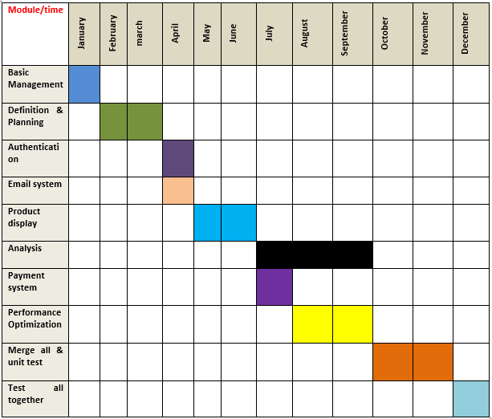

Table 1.1: Time Table for Single page E-commerce Web Application.

**1.6 Summary and Outline**

All over in this project is that we made an e-commerce site with single page application. It can load any page faster also even have many data. It make sure proper security of customers. It share information with customer automatically for their satisfaction. There also many advantages for admin too. So admin can handle site properly.

**CHAPTER TWO**

**LITERATURE REVIEW**

**2.1 Overview**

A literature review is a comprehensive summary of previous research on a topic. The literature review surveys scholarly journal articles, theses, books, and other sources relevant to a particular area of research. The review should enumerate, describe, summarize, objectively evaluate and clarify this previous research. We have seen many articles, papers, e-commerce website & project book to get more clearance for this project.

**2.2 E-commerce Definition**

E-commerce which is the abbreviation of [**Electronic commerce**](https://www.bartleby.com/topics/electronic-commerce) is the subset of e-business. E-business uses the digital technology to optimize the business activities of organization in order to increase the efficiency and effectiveness of operation and gain competitive advantages. To get more clearness on this topic we visited many e-commerce websites. At first we visited the first e-commerce website of our country which name become **Bagdoom.com[1]** from **akhoni.com.** We have also visited many famous websites like. ***startech.com*[5], *chaldal.com*[6].** Thoseare some running website of our country.

**2.3 Bring Clarity & Focus**

The literature review can plan an extremely important role in shaping our application problem because the process of reviewing the literature helps us to understand the subject area better and thus helps us to conceptualize our application problem clearly and precisely. It also helps us to understand the relationship between your research problem and the body of knowledge in the area. We also have seen some **Research paper** **[7]** based on e-commerce website.

**2.4 Broaden Knowledge**

It is important that you know what other researchers have found in regard to the same or similar questions, what theories and models have been put forward, and what gaps exist in the relevant body of knowledge. So firstly we try to find out what is the gaps on different website so that we can work on them and make our website easier and confidential among users. Now days most of the web site become very faster and easy to use so we also used single page application and more secure our site.

**2.5 Improve Methodology**

Going through the literature acquaints you with the methodologies that have been used by others to find answers to research questions similar to the one you are investigating. A literature review tells you if others have used procedures and methods similar to the ones that you are proposing, which procedures and methods have worked well for them, and what problems they have encountered. Through knowing this we get knowledge on documentation so that we can make our application fast. Like. ***Django documentation[2], Django rest-framework documentation[3], Angular documentation[4].***

**2.6 Summary**

End of the literature review we have get to know many things about website. We also get to know some shortage about website so that we can work on them. We get to know how to make website more attractive.

**CHAPTER THREE**

**MODELING & DESIGN**

**3.1 Overview**

We use **AGILE** methodology because we build our e-commerce website and also build a system so that we can analyze the behavior of customers. Agile SDLC model is a combination of iterative and incremental process models with focus on process adaptability and customer satisfaction by rapid delivery of working software product. Agile Methods break the product into small incremental builds. These builds are provided in iterations. That's why we will part our project into lots of parts or modules like Authentication system, Email processing, Payment system, Customer behavior analysis. At first, we design our database. After that parallelly work behavior analysis part with machine learning and web development. We made Authentication, Email system, Product display, Oder product system, Payment system, Analysis, Merge all & unit test, test altogether. For parsing muddle and work parallelly agile is best. That's why we select agile methodology.

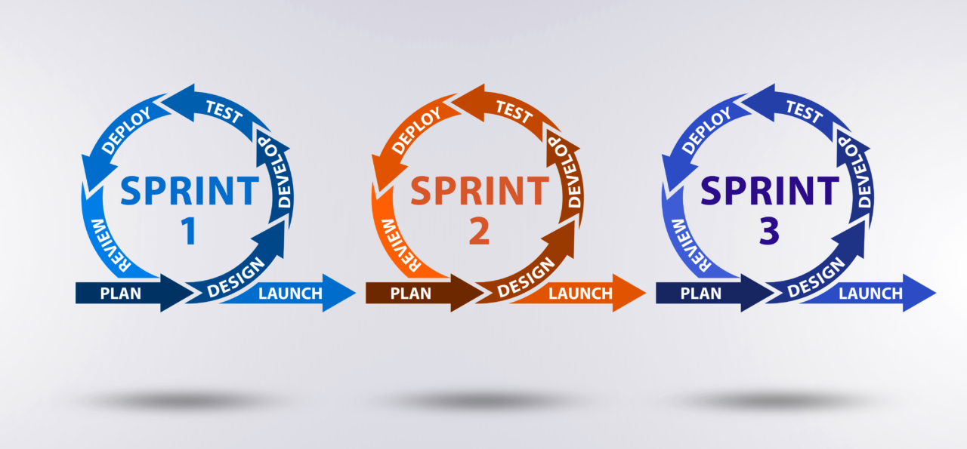

Figure 3.1 Agile Methodology for Single page E-commerce Web Application.

**3.2 Scoping & Planning**

This phase focuses on the planning of the project’s overall direction, including the definition of the project’s scope, objectives, and timelines. The deliverable from this phase is this Design Plan. At first we divided our projects into different parts. They are: Authority site setup, customer site setup, E-mail system, production display, payment system, login system etc. Than we start all of that part different phase so that we can develop our site on right time. When all of parts completed properly we will marge them all.

**3.3 Conceptual Design**

In this phase, the conceptual design of the methodology is developed and research on existing methodologies is conducted. We can show an outline of our project so that it can be understand so easily by anyone. For this we design Flow chart, Use Case Diagram & ER Diagram. Those are given below:

***3.3.1 Flow Chart***

A flowchart is a formalized graphic representation of a logic sequence, work or manufacturing process, organization chart, or similar formalized structure. The purpose of a flow chart is to provide people with a common language or reference point when dealing with a project or process. The flow chart of our project are design according to our planning. That are given

Management

Definition & Planning

Authentication

Not Feasible

Failed

Email System

Production Display

Payment System

Speed Test

Test

Passed

Merge all & Test

Confirmed

Figure 3.2: Flow Chart for Single page E-commerce Web Application.

***3.3.2 Use Case Diagram***

A use case diagram is a graphical depiction of a user's possible interactions with a system. A use case diagram shows various use cases and different types of users the system has and will often be accompanied by other types of diagrams as well.

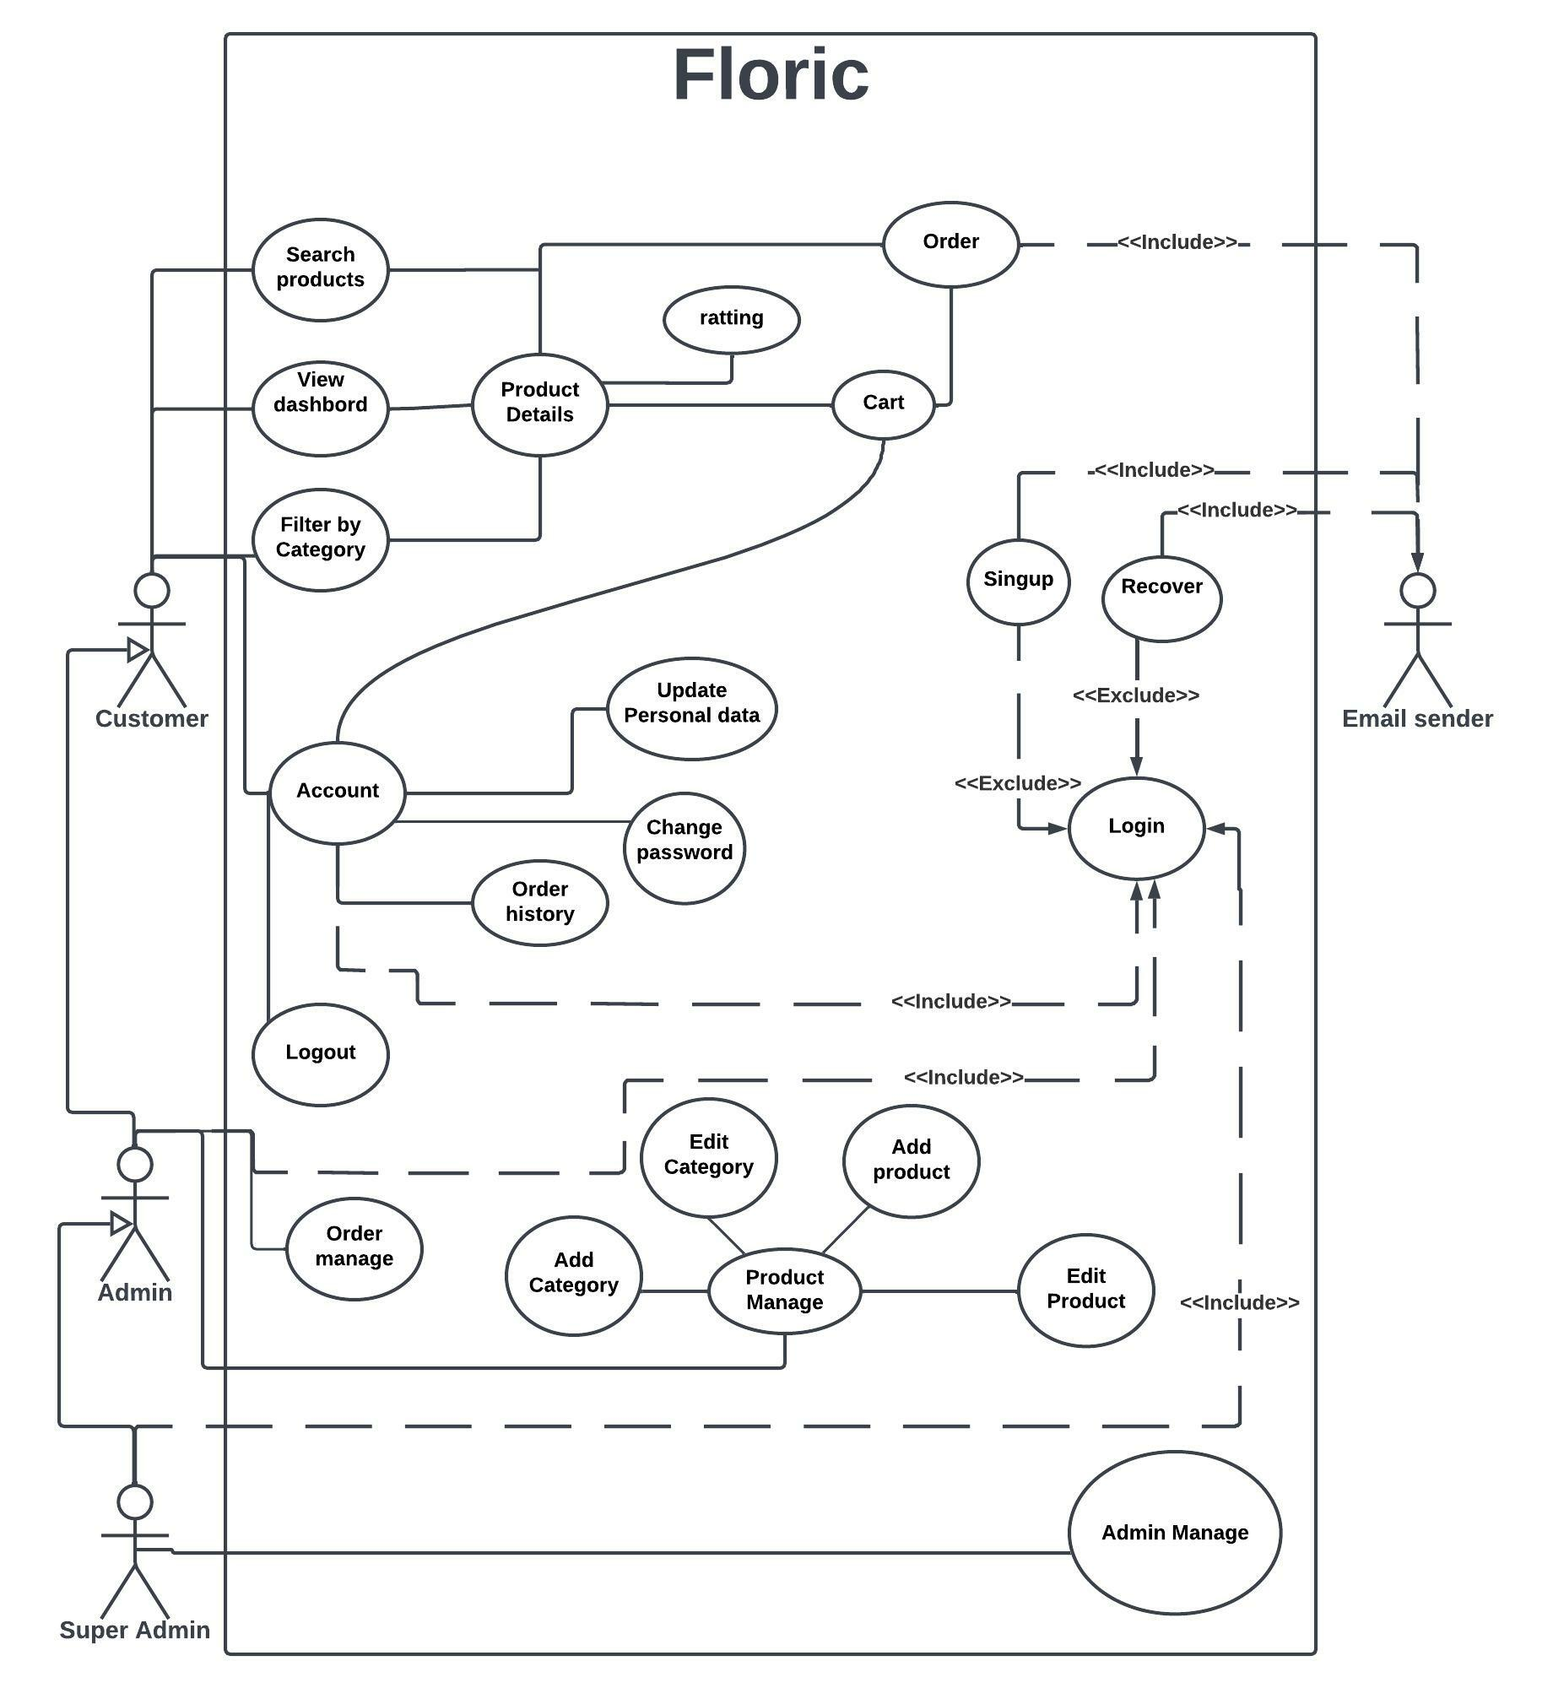

Figure 3.3: Use Case Diagram for Single page E-commerce Web Application.

***3.3.3 ER Diagram***

An entity–relationship model describes interrelated things of interest in a specific domain of knowledge. A basic ER model is composed of entity types and specifies relationships that can exist between entities.

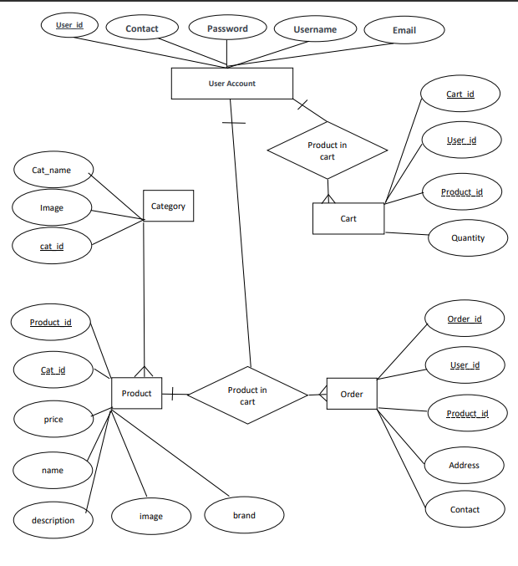Figure3.4: ER Diagram for Single page E-commerce Web Application.

**3.4 Development of Methodology**

The actual methodology is developed in this phase. Detailed descriptions of each task in the methodology are documented, including the objectives, inputs, approach, relevant models, applicable tools and techniques, outputs, and any references. The methodology is to be documented in an appropriate format, be it a Word document or HTML pages. If our methodology needs any development we can do it so easily because we have chosen AGILE model. As is has separate parts we can develop any part or add or remove any part without harming the other parts.

**3.5 Summary**

Final touches and summary to the methodology are made in this phase. The majority of these revisions come from experiences on the client project. Sample reports and any additional references are added to the methodology. So finally we will again revise and match with the technology is it satisfied with this methodology or not. And we can add some conceptual finishing tools.

**CHAPTER FOUR**

**SYSTEM SETUP, IMPLEMENTATION, & TESTING**

**4.1 Overview**

This is the most important part of our book. We will discuss on this part which system we have used on our web application, our authentication system. How much secure our web site is. We will also discuss how any person can create account on our application, login, logout, make order etc.

**4.2 Authentication System**

**4.2.1 Create Account**

To use our site at first any person have to create an account on our site. A visitor can also enter our site without creating any account and can see products, product details & ratting also. But to order anything that person must have to create an account. To make it more secure it need to cover some steps. Those are given:

***4.2.1.1 User Personal Data***

We have create a form where user can give his personal information to create an account on our site. Where user have to give First Name, Last Name, Email Address, Phone Number, Date of Birth, Gender, City, Zip code, Address, Password. There user must have to give their email, password, name. Otherwise our e-commerce application will not accept that person request and show pop up message to fill that form properly. After filling that form user have to click to submit for next process. There is must to tell that if an account is already created used an email. That email can’t be use again. Every account must have unique email.

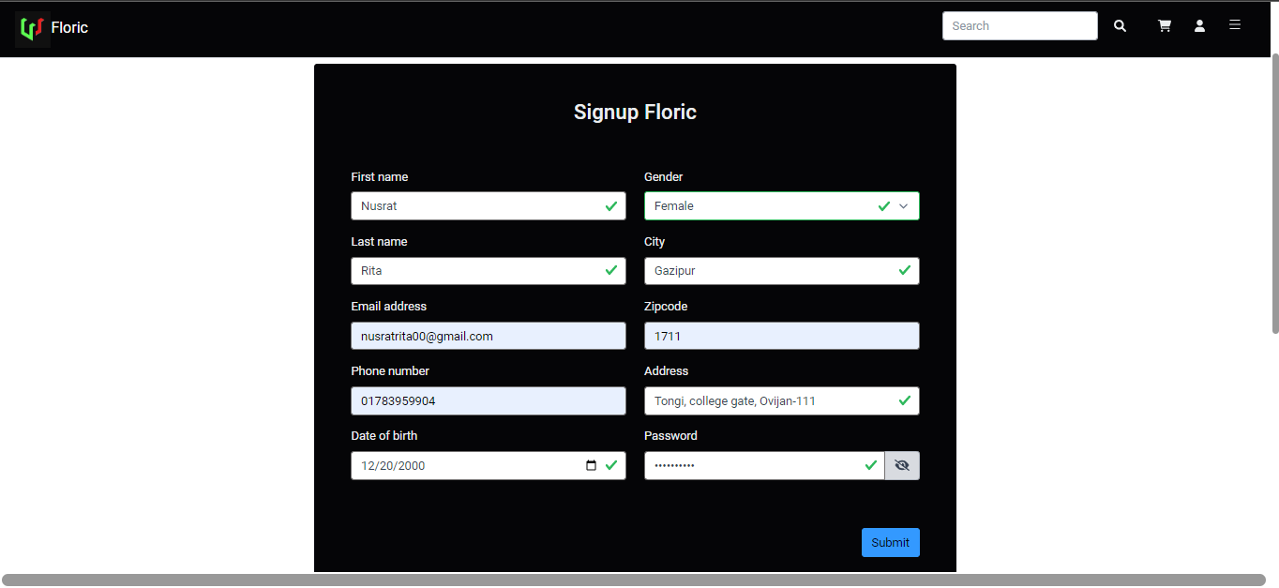

Image 4.1: Signup form on floric to Create an account.

***4.2.1.2 Store Data & Verification***

This is the part which make our site more secure and attractive. When used given their personal data and click submit button it save after verification into database via API as an inactive user. A database is already created in the backend of our application. Which store all user information. Then our API send an email to that given email address. That email has a link with its. That link has user **UID + Token + Expire date.** For each user it give different UID & token. Expire date gives the limited date for use that link.

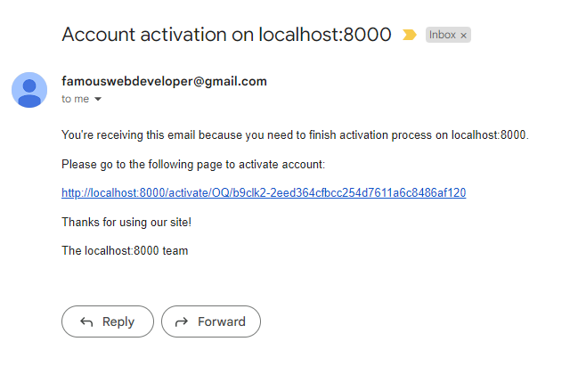

Image 4.2: User received email with link to active account.

***4.2.1.3 Activated to Login***

Verified email must be required. If that person open that mail or used that link only than his account will be activated. Also verify the email address. After that Change user activation status inactive to active. After click to that link it will lend that user to the login page. But it optional. User can log in after that whenever he wanted to. User only have to give email address and login password. And after click to submit it will enter our web site.

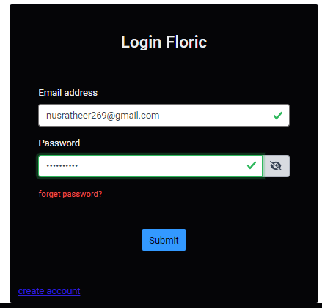

Image 4.3: Login form on floric after create an account.

**4.2.2 Login**

To login in our site user must already have an active account in our site. And it is as same as before. User only have to give to accurate email address and proper password to login. When site will have that mail address and password it will check it with the database. If valid it will return token and that customer UID. Both of them are unique for each customer to identify that customer properly. Or if the given information was not valid it will show a pop up message. There is also a helpful system on that site. It can storage **Token + UID + Expiry date** on that devise from where they logged in**.** Sothat**,** fornext use there is no need to give all that information again.

**4.2.3 Forget Password**

This system is now most common and useable for any customers. As we know to secure anyone personal information people use password for protection. But most of the time people can’t remember the password so they can’t get into that site to get product. On that time they can use forget password option. For using that user must have an active account.

***4.2.3.1 Match with Database***

If any user forget their password they have to click into **Forget password?** Which one is into down side on left side in the log in page. After click on that there will come a form where we only need to give user email address.

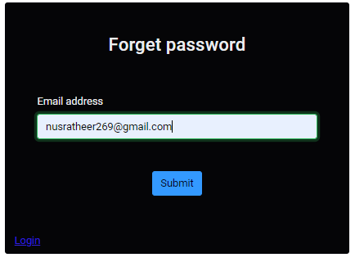

Image 4.4: Forget password form on floric.

User must have to give that email which one they used to create an account on our application. Then it will check with data base if the email address that user have an account or not. It database find that email it will check its active states.

***4.2.3.2 Verification Link***

When it find that that user states is active and there is an account its sends a verification link to that email. That link has user **unique id + token + expire date.**  So that site can verify if that user is real or not. As tell before UID and token are always unique. Using that link user can create a new password. For that user have to check his mail and click on that link.

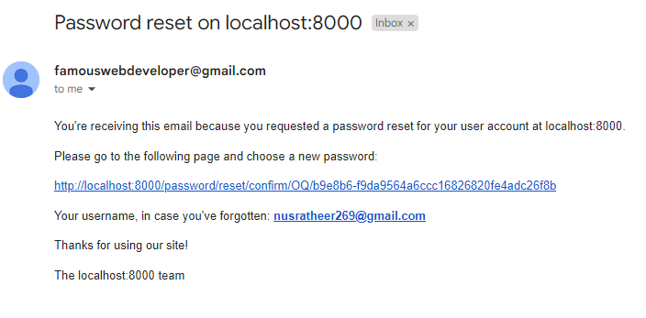

Image 4.5: Forget password email user to set new password.

***4.2.3.3 Set New Password***

When the user click on that link it will directly lent that customer a webpage to set new password. There they have to type a new password for their account and retype that new password for conformation. And click to submit button.

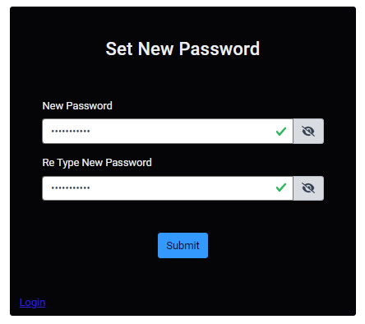

Image 4.6: Set new password form on floric for users.

Then that information went into our database and get this user by email & UID after get this user system replace the new password with previous password. After successfully set new password send an email and user can see the login page. User have to give his email and new password and can successfully enter our application.

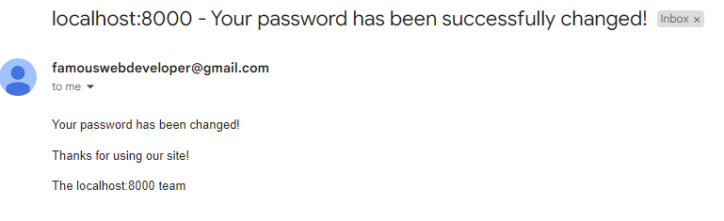

Image 4.7: Set new password success email to users.

**4.2.4 Change Password**

On some reason or for safety reason we want to change our password we can do it very easily on our site. First we must have to be logged in on our site. Then we have to go **Your Account** option. There we can see one option of change password. If we click there it will lend that user on a form.

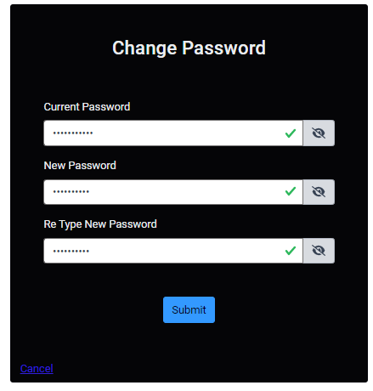

Image 4.8: Change Password form on floric.

On that form user have to give their current password, new password & Re Type New password. After filling this form when they will click to submit button. Then it will take that current and new password to database after validation process of it and replace that new password with current password based on UID. And to conform that password have been changed it will send an email to user mail. And there is no need to login again on our site. Our site will automatically save that new password on user account.

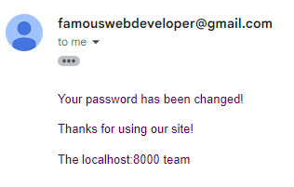

Image 4.9: Change password successful email to users.

**4.2.5 Change Email**

In some web site there is fixed the primary email & it make disappointed user. But on our site there is an option of changing primary email. For that we must have to be logged in on site. Then we have to choose **Your Account** option. There on the site of our email address we can see the change email system. Click on that we can see a form to change email address.

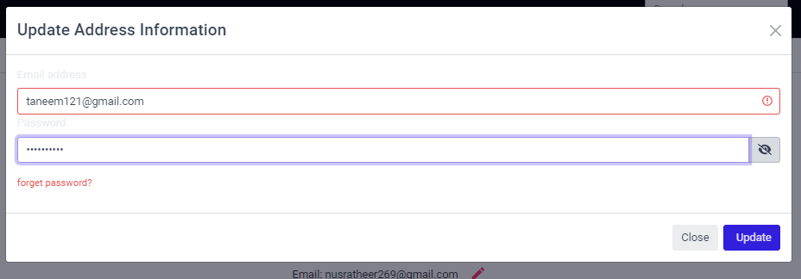

Image 4.10: Update address information form on floric.

There we have to change the previous email into new email and give the appropriate password of that account. There we can also use the system of **forget password?** After filling that form we have to click on **Update** option. Than it will take that information to database. Based on UID & token it will replace the new mail address with previous email. And it will send an email for successfully changing username.

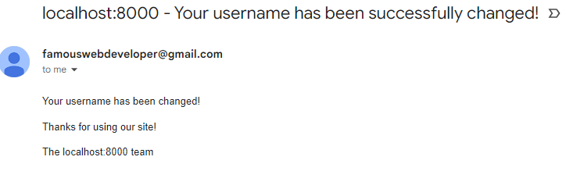

Image 4.11: Email Address change Successful mail to user.

**4.2.6 Log Out**

It is very necessary for anyone to log out from any site after used. Otherwise anyone can tried to get information from that person account. In most of the web site it is necessary to give password when user want to log out. It make the user irritated. But on our site it is very easy to log out. User must have to be logged in on his account. Only then user can see a Log out option beside Your Account option.

Logout Option

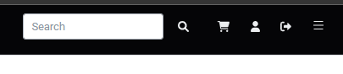

Image 4.12: Logout option on floric.

So user only have to click on that option and then he will log out in a sec. And the benefits are site will remove all of the storage of that user and also destroy the token. So that no one can do any harm to that user account.

**4.2.7 Security**

Website security is the protection of your site from malicious online attackers that can access, alter and steal your site’s content and data. It should also protect the personal data and privacy of your site's users. Every individual or business with a website should have a comprehensive understanding of [**cybersecurity basics**](https://www.wix.com/blog/2022/04/cybersecurity-basics/) to ensure they're website is safe from attacks. We used 2 type of security system on our site. They are given below:

***4.2.7.1 Hash Password***

Hashing is the procedure of translating a given key into a code. A hash function can be used to substitute the data with a newly generated hash code. Hash algorithms are generally used to offer a digital fingerprint of a file's contents often used to provide that the file has not been changed by an intruder or virus. Hashing turns your password or any other piece of data into a short string of letters or numbers using an encryption algorithm. Only user can decrypt data by using that particular hash. If a website is hacked, cyber criminals don't get access to your password. Instead, they just get access to the encrypted “hash” created by your password. In our web site we used:

**Security key + password = Hashed password.**

***4.2.7.2 Token System***

An authentication token allows internet users to access applications, services, websites, and Application Programming Interfaces System (APIs) without having to enter their login credentials each time they visit. Token-based authentication is a protocol which allows users to verify their identity, and in return receive a unique [**access token**](https://www.okta.com/identity-101/access-token/)**.** In our site we used for token:

**Hash password + Security key + User unique id + Expired date and time.**

On previous every part we show that all time we have sent and token with every information to make user information more accurate.

**4.3 Dashboard**

A dashboard is a visual display your data. While it can be used in all kinds of different ways, its primary intention is to provide information. In this part we will discuss about the first or front page of our site. There we can see one page web site logo, Navbar, Category of products, Pagination, Footer.

**4.3.1 Navbar**

On the left side of our navbar we have the logo of our web site which name is **FLORIC**. Which means happiness. We will try our best to make feel pleasure while they using our site. On the right side we have search bar, cart, profile, logout, sidebar. Those are showing now.

Search bar

**P**rofile

LOGO



CART

Side Bar

Image 4.13: Logout option on floric.

***4.3.1.1 Search Bar***

A rectangular field on screen that accepts typed-in text in order to look up something or launch a search. On our search bar we can search any product by many things like. Products name, 'description', 'color', 'brand', 'price', 'product_category_name’. If anything of this match with our dataset or products. It will show those products on screen. It will also show the related products.

***4.3.1.2 Cart***

Now a days cart become one of the most important part on an e-commerce web site. So we also give that facilities to our users. If user like any product. And he want to see other product or he doesn’t want to buy it now. So user can add it to his cart. He can add many product to his cart. It will save to database and also he can see those products and total amount of those products. He also can update the quantity of product and can also remove any products from cart. By click on place order he can buy those products anytime.

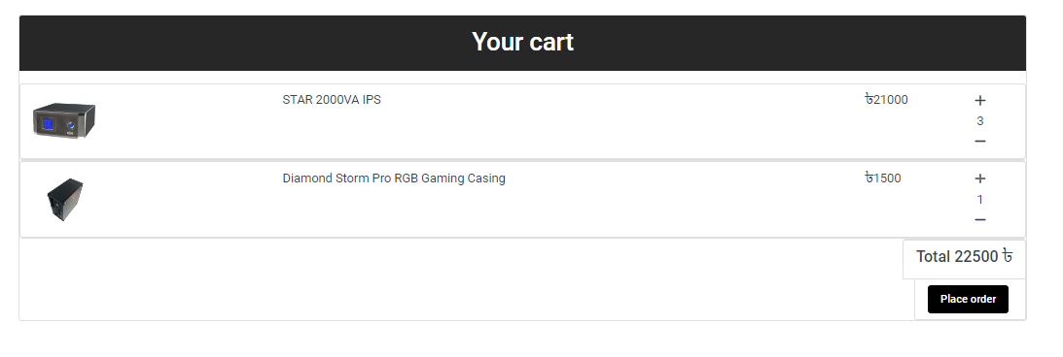

Image 4.14: Your cart form on floric for customers.

***4.3.1.3 Profile***

A profile is a short description of the user. Its shows them there information what they give us when they open that account on out site. It has three parts profile, My Order, Change Password. It also shows user profile picture and email address. We already show how user can change their password. Other will discuss now.

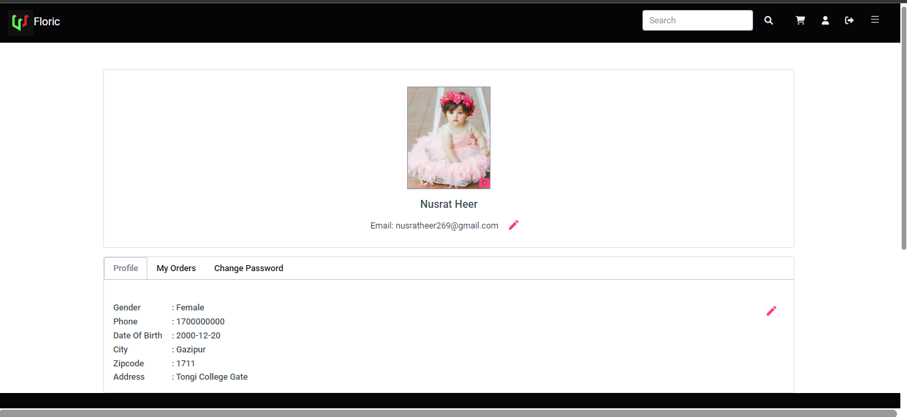

Image 4.15: User profile on floric.

1. **Edit Profile**

User can change his profile anytime and update his given information. First he have to go **Your Account** option. Then there is a red pen logo by click on that there will came a form call Update Address Information. There he can update his First Name, Last Name, Mobile Number, Date of Birth, Gender, City, Zip code and full Address. After changing on them he have to click on update. Then it will show the updated details.

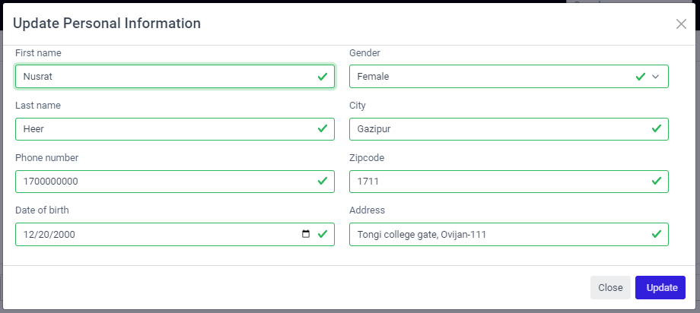

Image 4.16: Update personal information form on floric for users.

1. **Change Profile Picture**

Profile picture is not a mandatory part but now a days young generations like to changes their profile picture time to time. So we also have created an option of changing it. It is very easy to edit on user account user can see a red camera mark on the right bottom side of his profile picture. He have to click on that and there will come a page on his screen Update Profile Photo. There is a button called Choose file on the right side bottom on that form. Click on that it will show the option of choosing photo of that devise where they will use that site. Then they have to choose their liked photo and click on open option if they are using pc. Then they can see their updated profile photo.

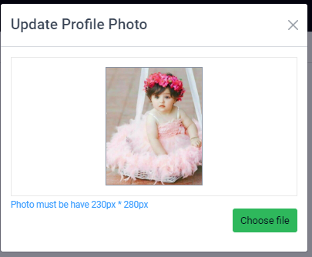

Image 4.17: Change profile photo on floric.

1. **Show Orders**

User can also see their ordered item on My Orders option on his account. There they can also see whole details of their previous orders. It shows products picture, products name, Quantity & price of each products. It also make them sure that their order had been taken.

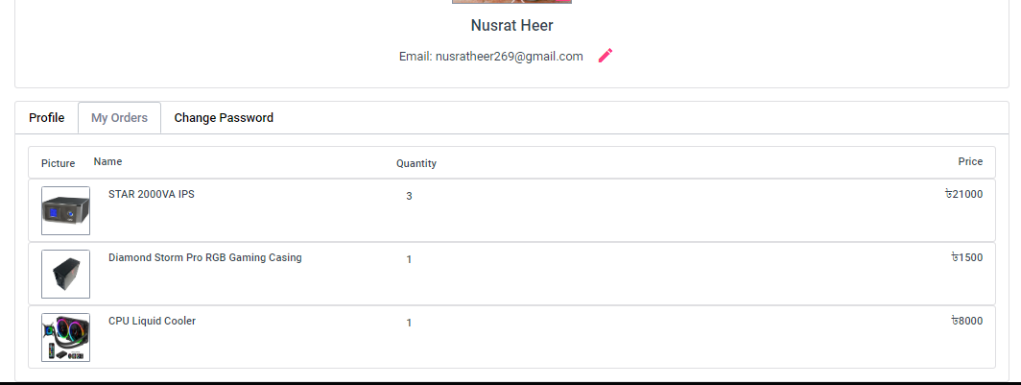

Image 4.18: My order form for users on floric.

***4.3.1.4 Log Out***

It is the easiest part of our site. There is a log out logo on the right upper side of our web site. User only need to click on that part it will logged him out from our site. Not only that it will remove all of the storage of that user and also destroy the token.

***4.3.1.5 Side bar***

A sidebar is usually a set-up column that is put into the left or right of the webpage's main website. They are usually used for displaying different types of additional information for users. On our side bar we show them all the category that we have on our web site. This side bar also have a scrolling system so that user can see all the categories to fine their wanted products easily.

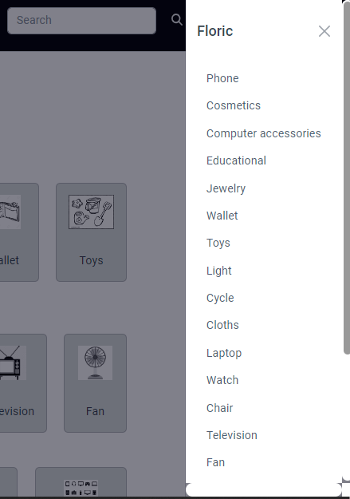

Image 4.19: Sidebar on floric showing categories.

**4.3.2 Category**

Categories group individual Web pages together based on a similar subject or theme. Categories help in organizing products in a way that makes it easy for visitors to find out what they're looking for. It is the first thing that any user can see on our web site. There Load all this category dynamically. And all the categories have photos related on their theme so that if any user doesn’t understood the name of category he can understand it by seeing photo.

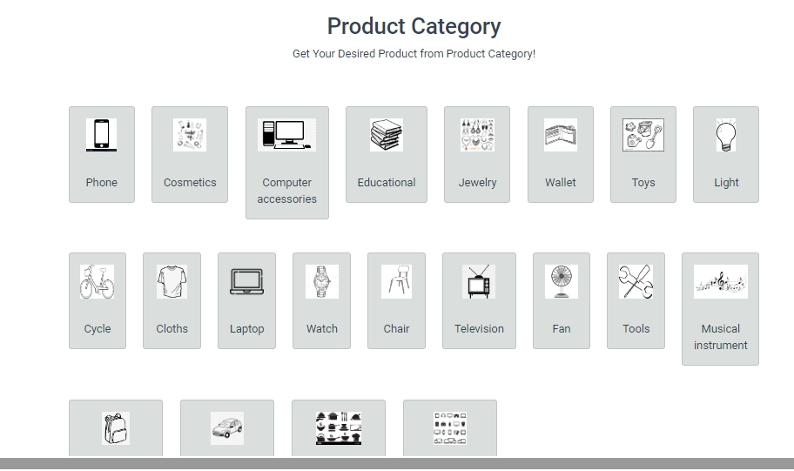

Image 4.20: Product category showing on first page.

**4.3.3 Products**

A product is the item offered for sale. A product can be a service or an item. It can be physical or in virtual or cyber form. Every product is made at a cost and each is sold at a price. The price that can be charged depends on the market, the quality, the marketing and the segment that is targeted. It is the 2nd part of the 1st page of our site. Its shows product name with its price and picture. There can show different categories products at a time. By click on each products user can see products details. It normally try to suggest user the most selling products or most demanded products.

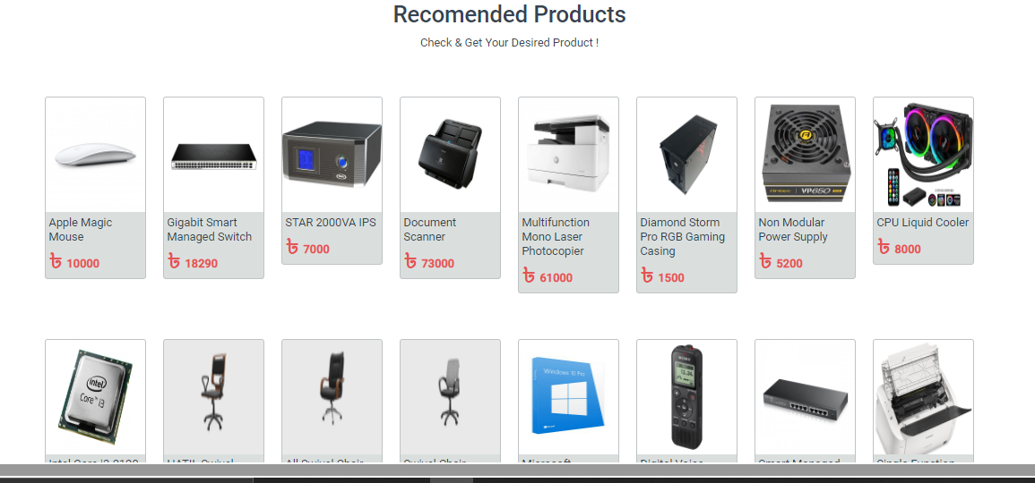

Image 4.21: showing products on the first page of floric.

***4.3.3.1 Product Details***

After click on any product user would like to know about they will find the details of that item. There on the left site it will show pictures of the products. There can be add maximum 4 picture. There is an arrow sine to see the next pictures of the products. On the right side it show product name, Brand, Model, color, available or stock out, price of it. Also there have options to add to cart or buy now.

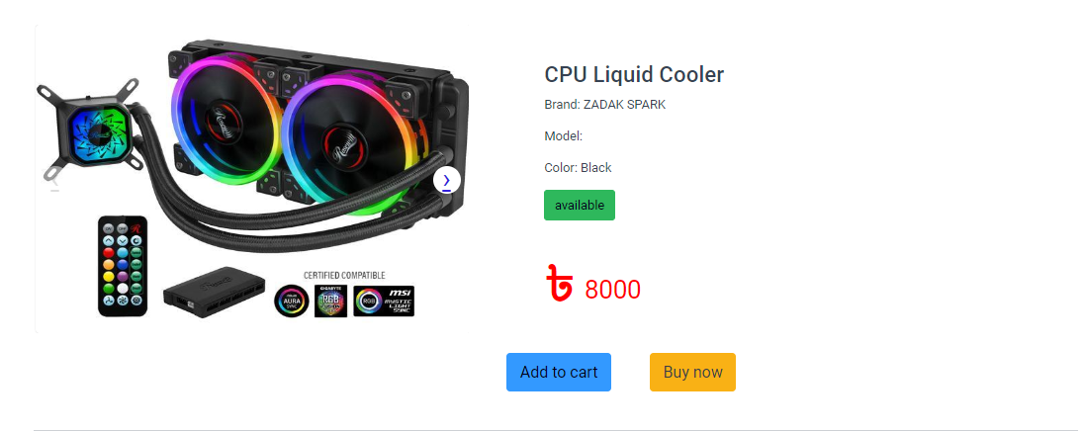

Image 4.22: One product showing page on floric.

On the next part of this page it shows the details information about the product. Then some specifications of it like color, weight, size etc. it make sure that buyer can know the full details about the products and became satisfied and have faith to buy.

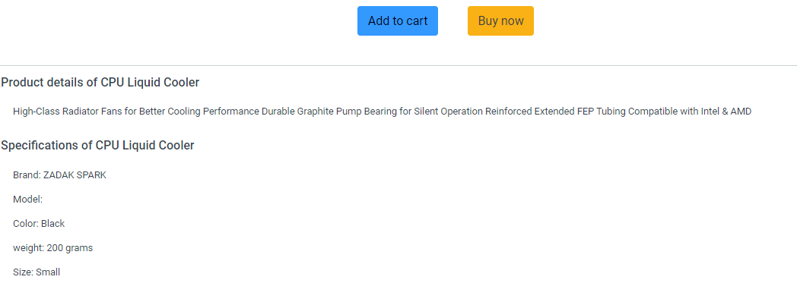

Image 4.23: One product details showing page on floric.

***4.3.3.2 Ratting***

Generate Trust is the first thing by seeing ratting. Today's shoppers trust the reviews of strangers more than they trust the advertisement from a company. Strengthen Marketing also can effort by it. It drive More Revenue. Our rating system is in down after the specification of product. We have 5 starts for ratting. If its ratting is five that means the quality of that product is good. If rating is 3 or 4 its means it not a bad product. But if the ratting is less than 3 that means it not a good item.

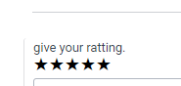

Image 4.24: Ratting option product showing on floric.

***4.3.3.3 Comment***

There also have a comment box under the ratting system. It make that trust more powerful. User can good comment and bad comment too if there is any fault on the product. After writing the comment user have to click submit button. After that it will be published and other user can also see their comment.

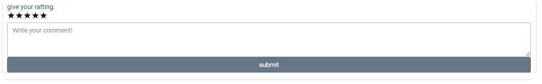

Image 4.25: Ratting & comment option of product showing on floric.

**4.3.4 Pagination**

Pagination is the method of separating digital content into different pages on a website. Users can navigate between these pages by clicking links, often in the form of numbers located at the bottom of a page. Paginated content is typically related by some common theme or purpose. Our pagination has 2 parts. One by which we can move one by one page. We can go next and we also can go to previous page. Another part by which we can go directly to the next page and also directly came to the previous page. We can also set the number of products what we want to see on the screen at a time in one page. We follow the following roles to set pagination.

**Page size + page index   ----->**

**Product (50) =   page size *(page index -1) to page size * page index**



Image 4.26: Pagination option on floric.

**4.3.5 Footer**

The website footer is the section of content at the very bottom of a web page. It typically contains a copyright notice, link to a privacy policy, sitemap, logo, contact information, social media icons, and an email sign-up form. In short, a footer contains information that improves a website's overall usability. In our web site footer first part is the suggestion of product. Its and text type system where user can write there wanted products so that admins can know about their demand.

In 2nd part is also divided into three parts. They are:

1. **Customer Service:** There is a Help canter from where user can know how to use our site. Next part is Report Us, there user can report about any problem or any seller or any products. Next they also can submit complain about any product or any seller. Lastly we have policy and rules from where user can know about our business policy and also can know the rules of our site.
2. **Contact us:** There we give some basic information so that if emergency user can connect with us very easily. So there we have given mobile Number, Email Address, Hot-line.
3. 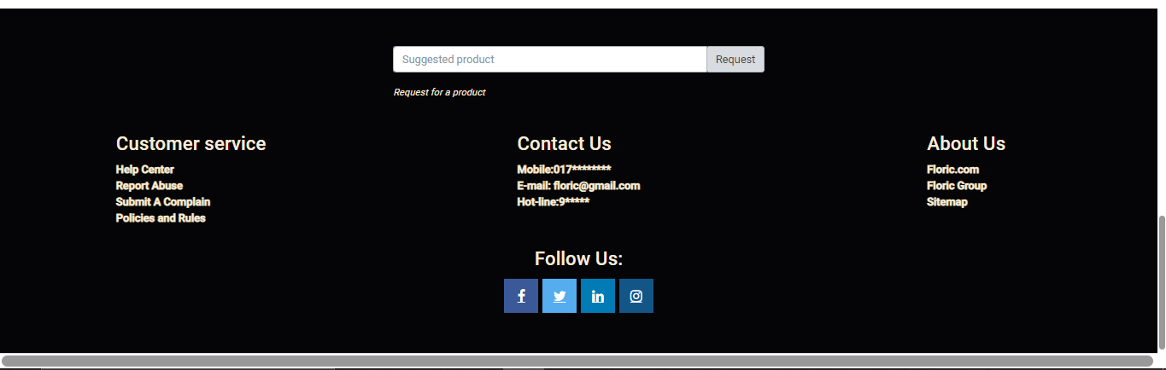**About Us:** There we have given information of our site. Like floric.com which is web site link. Details about floric group people. Sitemap to know about this site.

Image 4.27: Footer part on floric.

Lastly we have given some social site link so that user can follow us there also. There we have given Facebook, Twiter, Linked in & Instragram account link with their logo. To make this part we have used html and for design we have used CSS.

**4.4 Admin Panel**

Admin panels are created with specific tasks in mind and contain functions that help users focus on the functionality, content, and important data. Consider working with simple colors, fonts, and shapes not to overwhelm users with visual information.Ouradmin panel had 2 parts to control the web site. They are: **Admin** & **Super Admin.**

**4.4.1 Admin**

To handle any site or to monitoring always there need some admins. Admin has some special power from a user. Admins are also users but they can see the activities of other users. They also can add products, categories, update products & categories, edit & delete product etc. when a user is also an admin he can see an option called **Admin Panel**. When user went to his account he can see this option on the upper right side of his profile picture. After click on this there will came a new page on his screen. There are 5 phase on this page but an admin can only see 4 of them. They are given:

***4.4.1.1 All Orders***

It is the 1st phase of this page. It show us the ordered products by users. There we can see all the products parallelly. Products picture can see on the first row. 2nd row show us the products name. 3rd row show us the products id. As we know before every products has unique id so there it can identify products details and is it legal or not! On the fourth row it show us the order time. Order date, month and year. In 5th row we can see the Quantity of the products. How many item of one product wanted by a user. In 6th row we can see the price of products. If the Quantity on one product is more than one it will show the total amount of the product. Last and the most important row of this phase is status. An admin can change the status of any products. There are five type of status system on our site. Cancel, processing, warehouse, deliveryman, delivered. Admin can change the status of products anytime. If there is any fault or delay on the products so admin can change their status.

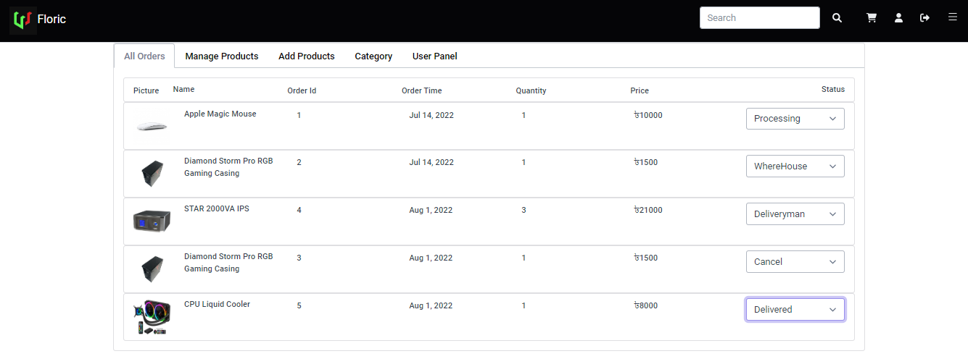

Image 4.28: All orders showing to admin panel on floric.

***4.4.1.2 Manage Products***

It is the 2st phase of Admin page. It show us the products details. When we went to admin panel and click on manage products there will come a page on our screen. Which have 9 rows. Products picture, products id, products name, quantity, model, price, edit, details, delete options. Click on edit we can edit any products details. Click on details of any product it will take us directly to the web site. So admin can see how does that product shows to other users. Is there every details are showing properly or not. It can make our site more perfect. If admin wants to delete any products they only have to click on red delete symbol. There also shows the pagination part. To see other products so easily. That’s all can an admin do.

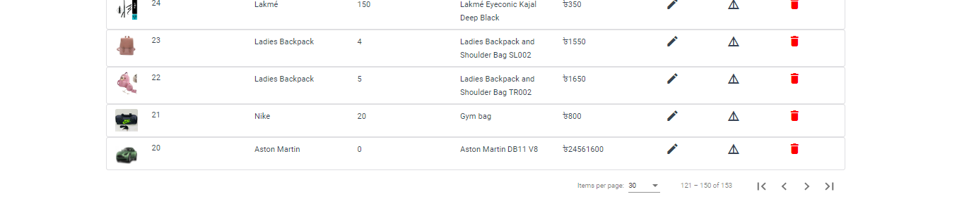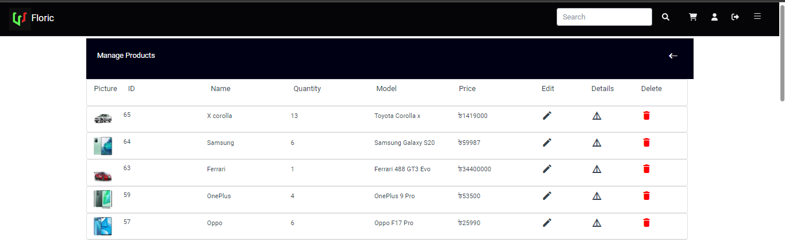

Image 4.29: All products showing to admin panel on floric.

***4.4.1.3 Edit Products***

It is the part of 2nd phase of Admin page. It show us the products details. When we went to admin panel and click on manage products there will come a page on our screen. And then we need to click on edit option on any product. Then it will lend us to the update product form.

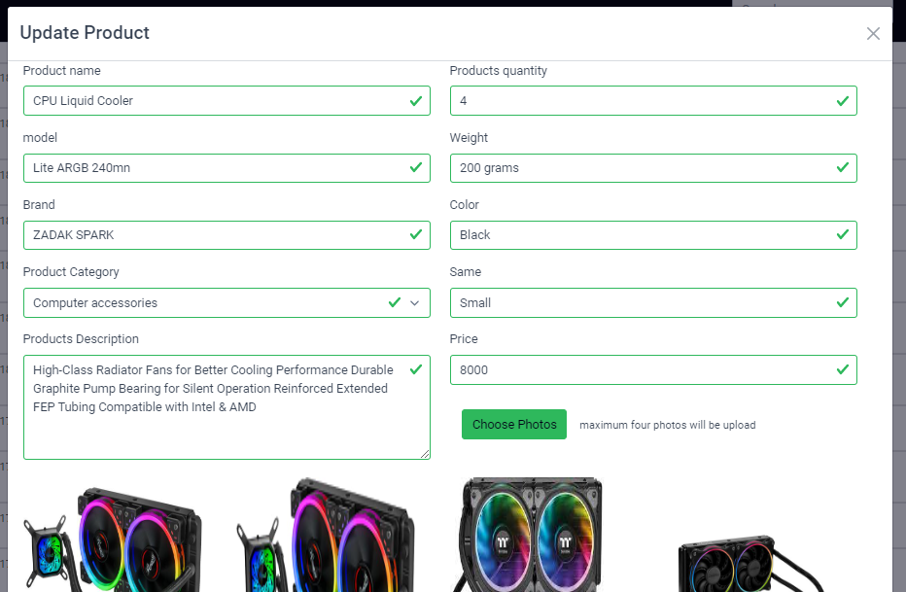

Image 4.30: Update Product option in admin panel on floric.

Where we can change any kind on details of the product. Like. Product name, model, brand, product category, products description, products quantity, weight, color, size, price, choose photos. All of the information can be changed. Also photos can be changed by click on choose photos like pervious described. Then admin have to click on update button. Than it take the token to the database and change the previous details and replaced it with the new details.

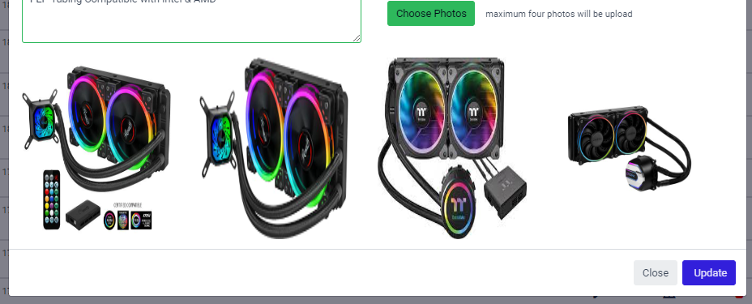

Image 4.31: Update Product photo option in admin panel on floric.

***4.4.1.4 Delete Products or Categories***

If any product is no more available. Or admin sees that products are not selling so user can delete that products easily. It is the part of 2nd phase of Admin page. When we went to admin panel and click on manage products there will come a page on our screen. And then we need to click on delete option on any product. Then it will show us a notification page. Which name is delete confirmation. There is a button called delete admin have to click on that. Then it will sent a product id and token. If user is an admin or super admin delete this product and success message. If it is not admin or super admin send error message.

The same process also have to do for delete any category. On admin panel we have to go on manage categories. There on 5th row we can see delete option. Click on that and do the same process as before.

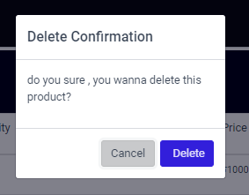

Image 4.32: Delete Product & category notification in admin panel on floric.

***4.4.1.5 Add Products***

Admin can add products to grow the business more. To do this admin have to go on admin panel and click on add product. Then it will show a form where admin can give information Product name, model, brand, product category, products description, products quantity, weight, color, size, price, choose photos(maximum 4 ). Then click on add product. After received all information from admin and send with token make a post request, if user is an admin or super admin and products data are valid save this product save message. If it is not admin or super admin or products    is       not valid send an error massage.

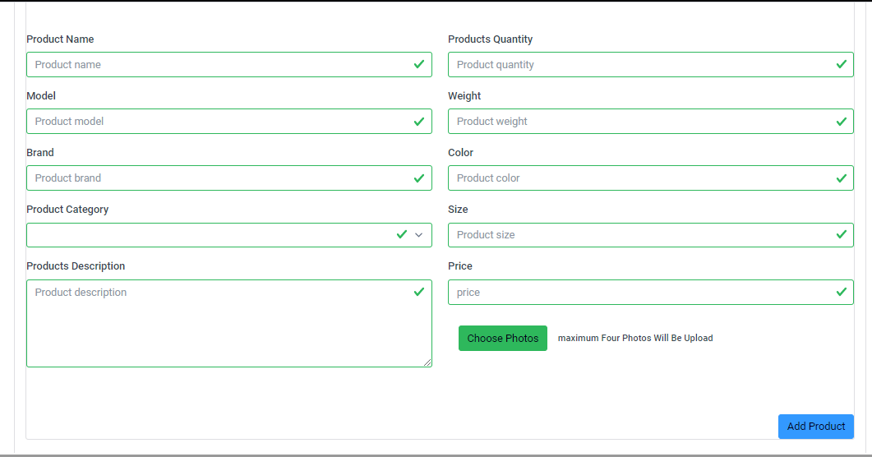

Image 4.33: Add product form in admin panel on floric.

***4.4.1.6 Manage Categories***

It is the 4th phase of Admin page. It show us the categories details. When we went to admin panel and click on manage categories there will come a page on our screen. Which have 5 rows. Categories picture, categories id, categories name, edit, delete options. Click on edit we can edit any products details. If admin wants to delete any category they only have to click on red delete symbol.

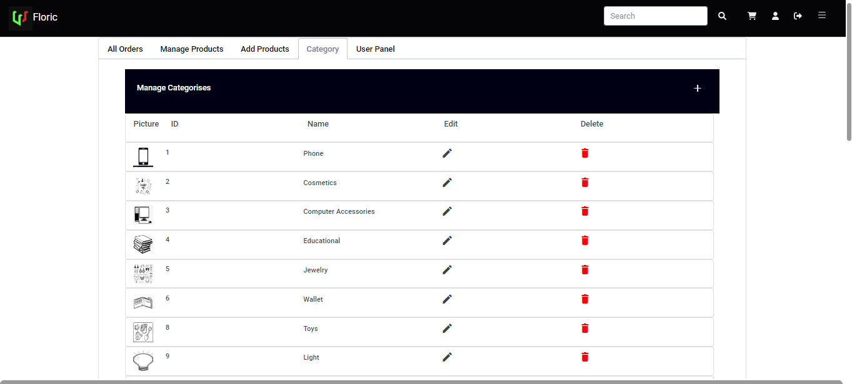

Image 4.34: Manage category page in admin panel on floric.

***4.4.1.7 Edit Categories***

It is the part of 4th phase of Admin page. It show us the category details. When we went to admin panel and click on category there will come a page on our screen. And then we need to click on edit option on any category. Then it will lend us to the edit category form. There we can change the category name and its photo by click on change photo. Than admin have to click on update button. Than it take the token to the database and change the previous details and replaced it with the new details. Than we can see the update category.

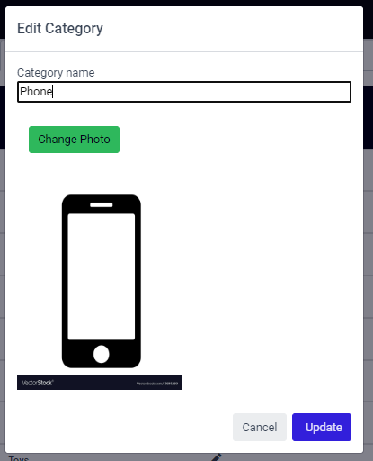

Image 4.35: Edit category form in admin panel on floric.

***4.4.1.8 Add category***

Admin can add category too so that user can find their wanted things so easily. To do this admin have to go on admin panel and click on category. Then it will show a form where we can see a (+) sign on the upper right side. After click on that we will see a form to add category. Where we can give a category name and one pic related with it. Than admin have to click on create button. Than it will take a token ad set a new category which will have its unique id. If it find the admin or super admin valid then it will update new category and we can see it on our site.

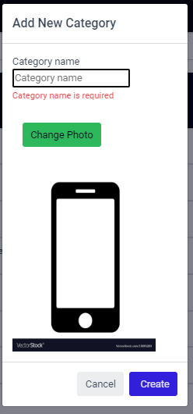

Image 4.36: Add New category form in admin panel on floric.

**4.4.2 Super Admin**

Super Admin is that person who has all the excess of everything. Who can add, delete any admin or user. Super admin can do all the things that an admin can do. Father that super admin can see the user panel. Where no admin has access to see anything. After click on user panel we can see a form where we can see the information of all the users. We can see user name, email, user id, admin or super admin or not, phone number. Not only that a super admin can make any user admin and super admin and also can remove from admin & super admin. So in generally he has all the power to handle anything on our web site.

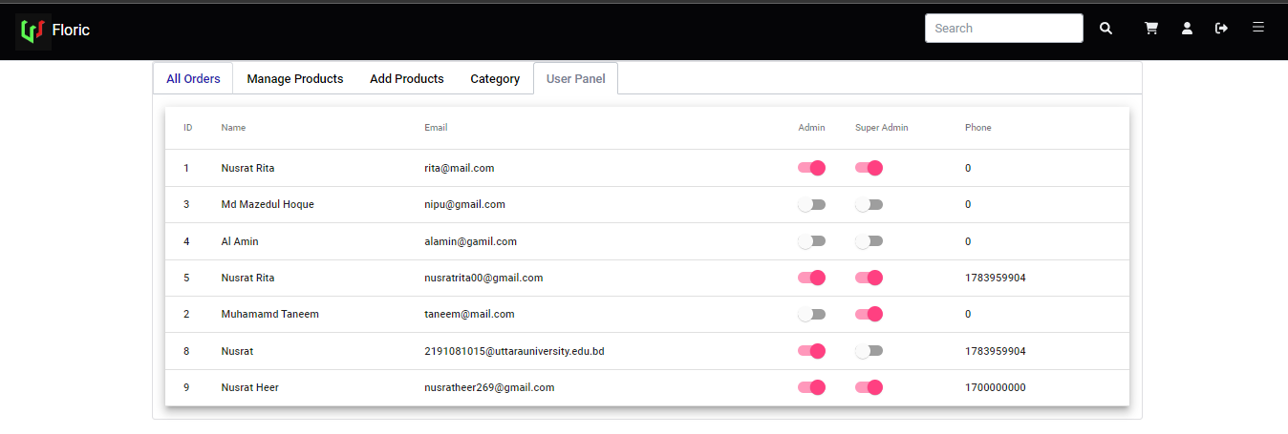

Image 4.37: User panel form in admin panel for super admin on floric.

**4.5 Order**

Order make that online site more powerful because user doesn’t need to go out for shopping they can order any time anything they would like. And it is not necessary that user must have to order now. User can add their wanted product to the cart so that they can make sure order any time. We divided our order part in 2 parts. They are: 1. Buy Now & 2. Add to Cart.

**4.5.1 Buy Now**

Buy now is the process by using this user can make order instant. When any user select the buy now option it lent the user to make order page. This page is also connected with add to cart. So it will show all the products picture, name, amount parallelly. This page has 3 phases. There details are given:

***4.5.1.1 Confirm items***

It is the 1st phase of this page. It show us the picture of the chosen item. It also shows item name. At the middle it shows the multiplication the amount of that item and its quantity. So that user can make sure which item how many they have ordered. At the right side it shows each item price individually and also show the total amount of all item together. If all are ok then user have to click to next to want to the next phase.

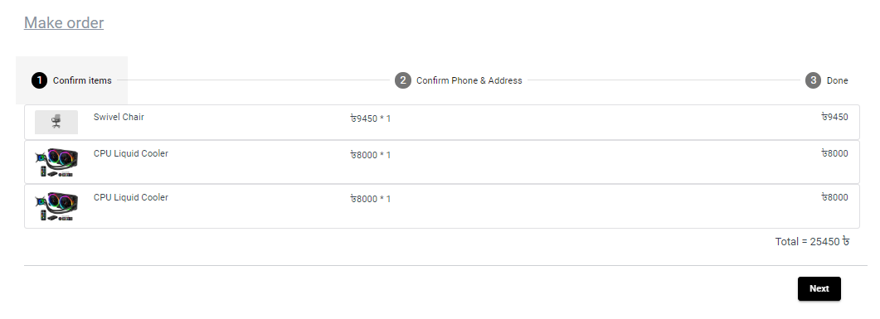

Image 4.38: Confirm order page for users on floric.

***4.5.1.2 Confirm phone & Address***

It is the 2nd phase of this page. It show us the option of given phone number and address. If user already given their phone number and address while opening account on this site it will automatically show them that. But if user didn’t give it before than they have to it now went to next phase. User can also go back from that phase if that want. Or if all information are given than they have to click on next again.

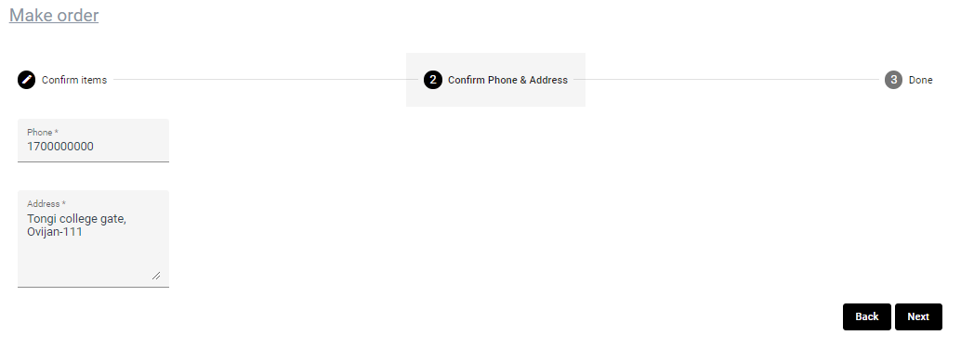

Image 4.39: Confirm phone & address page for users on floric.

***4.5.1.3 Place Order***

It is the last phase of this page. It show us the options select payment. We have 4 kind of payment options. They are: cash on delivery, Bkash, rocket, Card. On cash on delivery system user have to give money when they get the product. On the other 3 they have to pay first and then make sure the order. After selecting the payment option user have to click of done button. Then it take product id and check that product is valid or not. And also check the quantity of product are available or not. If yes return true and the order become confirm. The process is:

**Product id ---> check product id is valid + at least quantity is one if return true go to order**

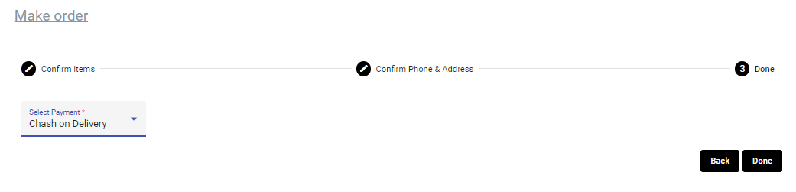

Image 4.40: Make order page for users on floric.

When order is completed user will get a confirmation mail. This mail will show product name, Quantity, bill, order id. Order id is unique for every customers.

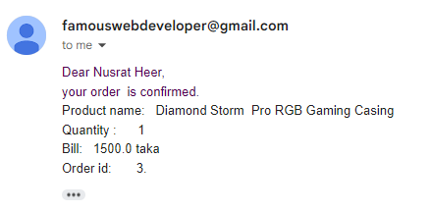

Image 4.41: Confirm order email for users on floric.

**4.5.2 Add to Cart**

The add-to-cart rate is **the percentage of visitors who place at least one item in their cart during the session**. Add-to-cart rates are important to track, since they can tell you about the success of your product selection, marketing efforts and site usability. There is always 2 system add with the product. One is add to cart. When we went to any product and we like the product but for now we don’t want to buy it so we can select the Add to cart option. It will directly lent us in to add to cart form and show us the product picture, name, amount and if we selected more than one product it will show us the total amount of them. User can also see the previous added products. And user can place order any time. When customer select add to cart its take product id & quantity. Check that product is valid or not. If valid return true and it save to cart. Its follow the following process:

**Product id + quantity ---> check Product id is valid + quantity if return true save to cart**

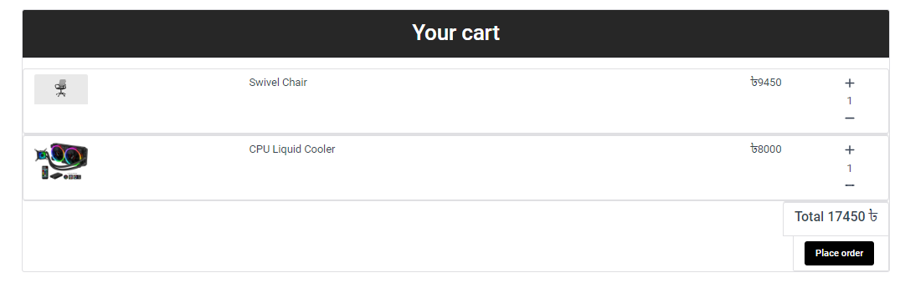

Image 4.42: Your cart page for users on floric.

After click on place order it will take us to the make order page. And the next things are as before said buy now system.

**4.6 Summary**

In our project, we have developed a single-page web application system. Where customers can open an account, order products, see product details, and make ratings & comments. Also, admins can add or remove products & categories, change product status, and super admin can see users and also can make them admin & super admin. we tried to keep it highly secure API also faster smooth page transitions, and make customer friendly user interface. In the future, we can implement a content base recommendation system that recommends customers' other products depending on their selected product. Our future plan is customer behavior analysis

**CHAPTER FIVE**

**RESULT ANALYSIS & BENCHMARKING**

**5.1 Over View**

Results Analysis (RA) is a functionality in SAP Controlling to valuate ongoing, unfinished activities, such as service orders, production orders, internal orders or projects at month-end. As we have completed our authentication part, web application parts, admin panel, order system and so on. Then we have try to analysis their result and find out the lacings on them and we also solved them. Then we have implemented a customer side and also create account to see is our web page working or not. After that we also have to face some error but we solve it easily as we have

**5.2 Result Analysis**

As we have completed our project our result is in front of us. Here we are showing some analysis part of our project.

**5.2.1 Create Account & make an order**

The flow of creating an account for a new customer and make an order are given:

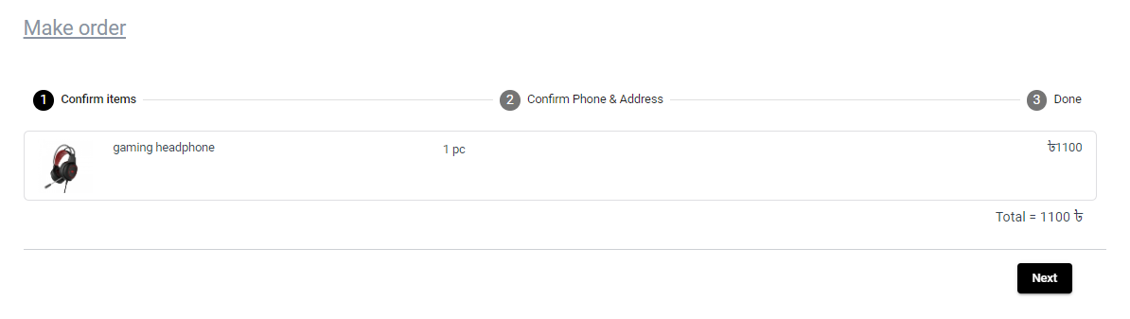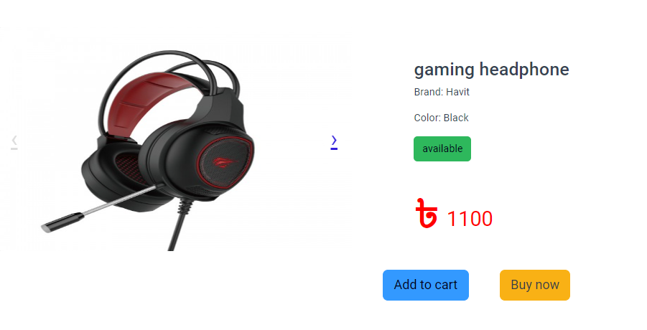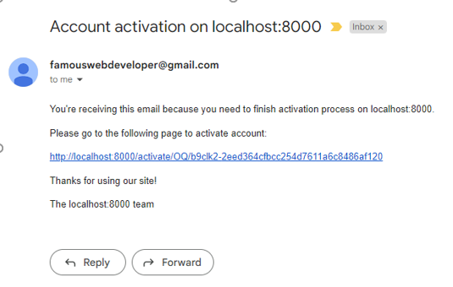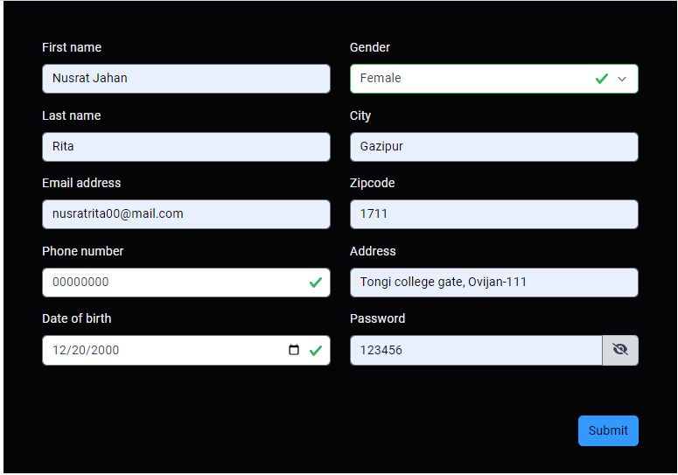

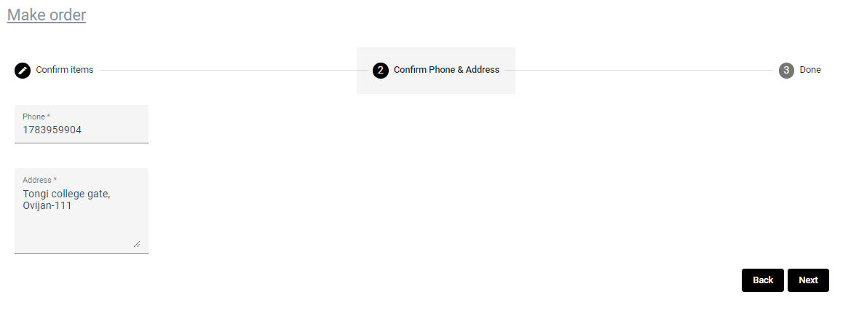

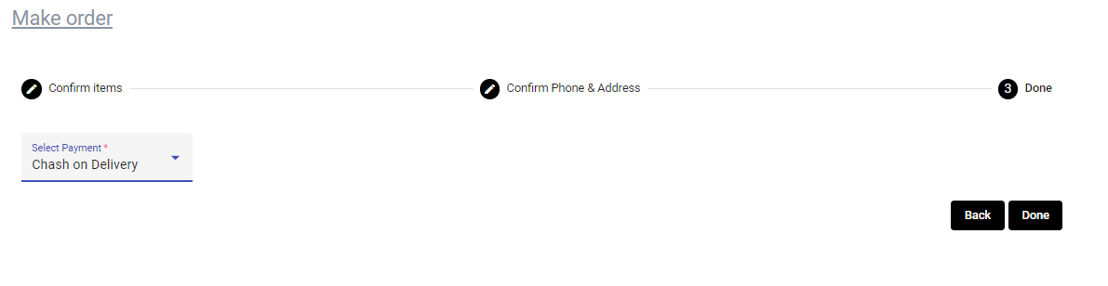

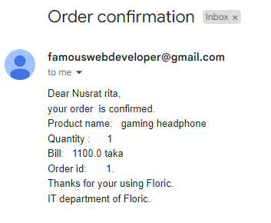

**5.2.2 Add product Process**

Only an admin or super admin can add products in this web page. A flow of adding a product is given:

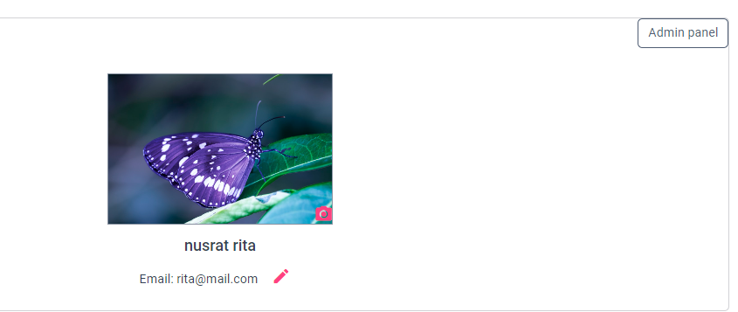

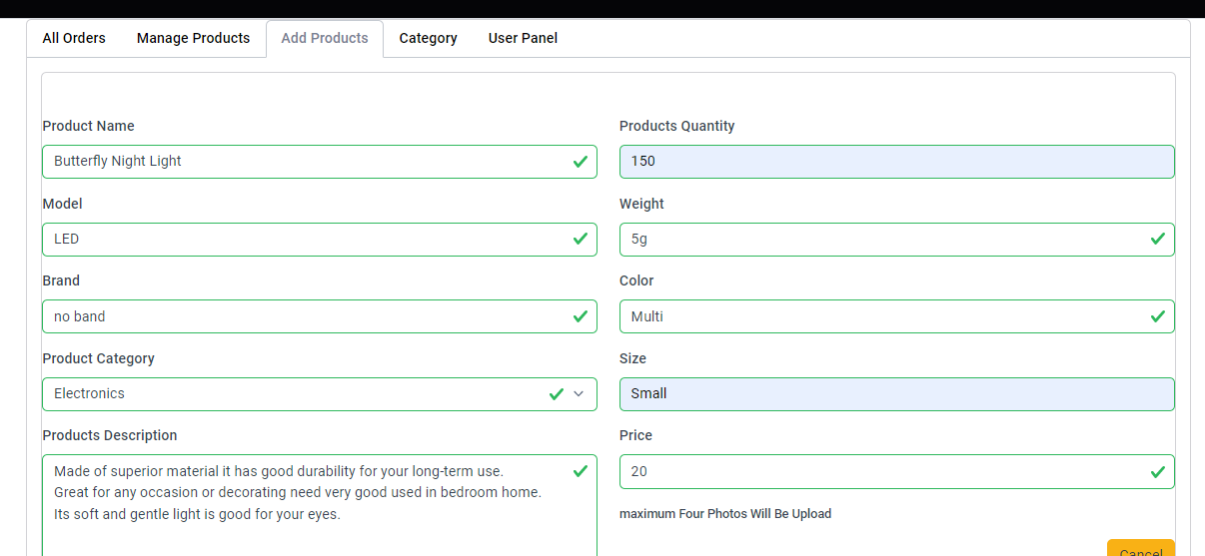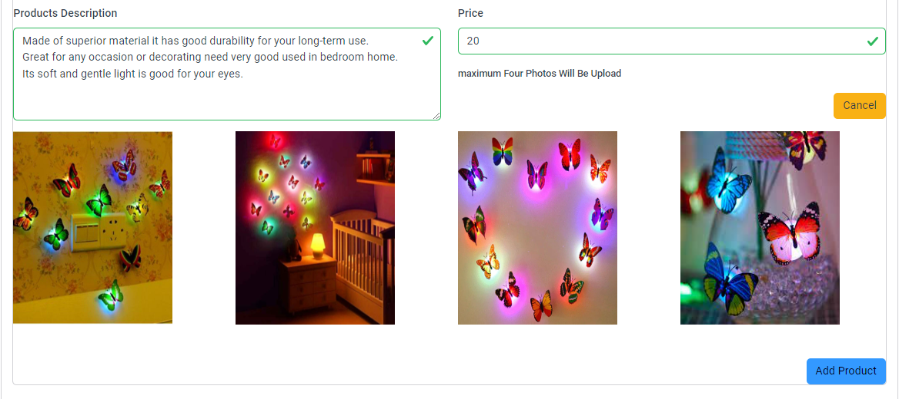

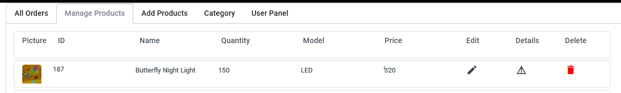

**5.3 Benchmarking**

**Resolver:**

* When the Component loads, data is preloaded.
* No chance to broke document object model (DOM).
* Component code is more meaningful and less cluttered.
* Code is centralized and modular.
* Hooking into the Router provides Resolver related events we can listen for.
* Error handling in a Resolver

**Interceptor:**

Angular interceptors manipulate the headers as they provide features such as authentication and authorization. The HTTP interceptors are used to protect the application Unwanted request. Interceptor can even convert the format of an API that we receive.

**Lazy loading:**

Lazy loading is an important feature that helps to **reduce the initial load time** since it loads only the necessary files first. Other required modules are loaded on demand when you navigate to their particular route. Now, you can take advantage of this feature to improve your app's load time.

**Gourd:**

The router's navigation guards allow to grant or remove access to certain parts of the navigation. Route guard, the Can Deactivate guard, even allows you to prevent a user from accidentally leaving a component with unsaved changes. We also use authGuard is used to protect the routes from unauthorized access in angular.

**Single page web application:**

* Quick Loading Time.
* Seamless User Experience.
* Ease in Building Feature-rich Apps.
* Uses Less Bandwidth.
* Uses a Lot of Browser Resources.
* Security Issues.

**5.4 Summary**

As par the Results Analysis (RA) we are successfully able to lough a single page web side. Which can give us many facilities. And there we have also leave many source to developed our page to analysis customer behavior.

**CHAPTER SIX**

**CONCLUSION & RECOMMENDATIONS**

**6.1 Project Outcomes**

In this project, we have used different techniques to achieve our target goals. We have solved our all-selected problems statement. We have implemented a website with single page application. In this entire project life-cycle, we have tried to make sure the best user experience for customers. We have implemented a way through which customers can easily move from one page to another without any loading as our website is a single page web application technique for fast loading. We have added all of the most used purchase gateways for customers so as not to fall in trouble. For our whole project, we have used the AGILE model in our project life-cycle. And in the future, we will add more reliable and dynamic technology to our web application.

**6.2 Limitations of the Project**

Nothing can be 100% perfect on this world. Everything have their limitations as well as we also have some limitations. Like.

1. **Tax Issue:** If customers want to pay on bkash or rocket we have to cut cash out money depend on products price.
2. **Fear:** As it is an online process customer could hardly trust on us to get correct product or pay on online.
3. **Product Suitability:** We can’t give all the options to have all kind of products on our website as word have million categories of items.
4. **Cultural Obstacles:** As our country is an Islamic country so we can’t provide other culture products so much it can occur loss in our business.
5. **High Labor Cost:** It is an online system still we need some labor to control our application and to give cash on delivery.

**6.3 Recommendations**

Our ecommerce site will lend itself to some of the following tips, but not to others. We’ll list the kinds of tactics we’ve seen our clients effectively implement.

1. Introduce Shoppers to New Items
2. **Save Potentially Lost Sales**
3. **Provide Social Proof**
4. **Generate Product Bundles**
5. **Make Sure Responses are Relevant and Timely**

**REFERENCE**

**1.**E-commerce website: https://onlineshoppingbd.org/bagdoom-com/ Visited Date: 03 JANUARY,2022

**2.** Django documentation: https://docs.djangoproject.com/en/4.0/ Visited Date: 08 JANUARY,2022

**3.** Django rest-framework documentation: https://www.django-rest-framework.org/

Visited Date: 12 JANUARY,2022

**4.** Angular documentation: https://angular.io/docs Visited Date: 18 JANUARY,2022

**5.** E-commerce website: https://www.startech.com.bd/ Visited Date: 23 JANUARY,2022

**6.** E-commerce website: https://chaldal.com/ Visited Date: 23 JANUARY,2022

**7.** E-commerce research paper: https://www.researchgate.net/publication/304703920_A_Review_Paper_on_E-Commerce Visited Date: 25 JANUARY,2022

**8.**E-commerce website: https://www.daraz.com.bd/ Visited Date: 27 JANUARY,2022

**APPENDIX A**

**EXAMPLE CODES**

**CODES FOR INTERCEPTOR**

import {AuthService} from './auth.service';

import {Injectable} from '@angular/core';

import {HttpEvent, HttpHandler, HttpInterceptor, HttpRequest} from '@angular/common/http';

import {Observable} from 'rxjs';

import {environment} from 'src/environments/environment';

@Injectable()

export class AuthInterceptor implements HttpInterceptor {

BACKEND_URL = environment.apiUrl;

id: any | null = '';

constructor(private authService: AuthService) { }

usedUrl = [

this.BACKEND_URL + 'api/cart/',

this.BACKEND_URL + 'api/profile/',

this.BACKEND_URL + 'api/orders/',

this.BACKEND_URL + 'auth/users/set_password/',

this.BACKEND_URL + 'auth/users/set_email/',

]

isfree(url: string) {

console.log(url);

let mainUrl = url.split('?')[0];

mainUrl = mainUrl.replace(/[/]\d{1,12}[/]/, '/'); //id remover

console.log(mainUrl);

for (let i = 0; i < this.usedUrl.length; i++) {

if (mainUrl == this.usedUrl[i]) {

return true;

}

}

return false;s

}

intercept(

request: HttpRequest<any>,

next: HttpHandler

): Observable<HttpEvent<any>> {

if (this.isfree(request.url)) {

console.log('header added');

const authtoken = this.authService.getToken();

request = request.clone({

setHeaders: {

Authorization: `jwt ${authtoken}`,

},

});

}

return next.handle(request); }}.

**CODES FOR GUARD**

import { Injectable } from '@angular/core';

import { ActivatedRouteSnapshot, CanActivate, Router, RouterStateSnapshot, UrlTree } from '@angular/router';

import { Observable } from 'rxjs';

import { AuthService } from './auth.service';

@Injectable({

providedIn: 'root'

})

export class AuthGuard implements CanActivate {

constructor(private authService: AuthService, private router: Router) {}

canActivate(

route: ActivatedRouteSnapshot,

state: RouterStateSnapshot

):

| Observable<boolean | UrlTree>

| Promise<boolean | UrlTree>

| boolean

| UrlTree {

this.authService.autoAuthUser();

this.authService.redirectUrl = state.url;

console.log('router accessss',state.url);

localStorage.setItem('redirectUrl',state.url);

console.log(this.authService.redirectUrl);

const isAuth = this.authService.authenticationStatus();

console.log(isAuth);

if (!isAuth) {

this.router.navigate(['/auth/login']);

return false;

}

return true;

}

}

**BSc in CSE SINGLE PAGE E-COMMERCE WEB APPLICATION UU, FALL 2022**